JavaScript:

KeyWords:

* Js main Asy word jiss sy kuch ho sakhta hai wo saray word j sky keyword hoty hai .

Example:

1. If
2. Else
3. For
4. While
5. Do
6. Else if
7. Function

Word:

Asy word jin ka koi matlab nahi hota usy word khty hai

Example:

1. Rafay
2. Ai
3. Ali

📦Chapter 1: Variables & Declarations

🧠 What are Variables?

Variables are containers that hold data. They help us store, reuse, and update information in JavaScript — from simple values like numbers to complex data like arrays and objects. Think of a variable as a box with a name on it. You can put something inside it (a value), and later check or change what's inside. In JavaScript, you create these boxes using keywords: var , let , or const

🧪 var, let, and const – Line-by-Line Comparison:

How we can created the variable:

Example:

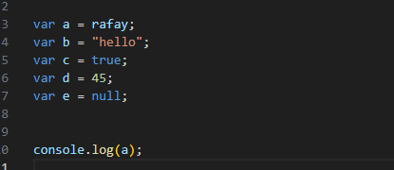

Example:



Example:

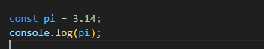

Declaration and initialization:

Example:

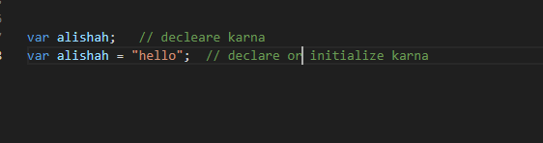

Var:

* Window main add hota hai.
* Ye hamesha function scoped hota hai.
* Ap phir sy declare kar sakhtay ho error nahi ay ga same name.

Example:

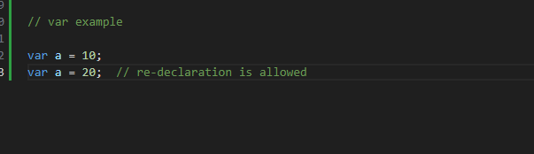

Const:

* Value change nahi ho sakhti aikbar declare hoti hai.

Example

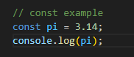

Scope (global , block, Functional)

Function Scoped:

* Aik jo function ham ny create kiya hai us usy var ko us main use kar sakhty hai function scoped.

Example:

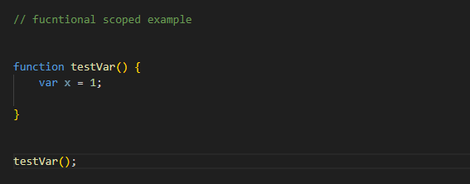

Global Scoped:

* Variable ko openly kissi function ky bhair rhkny ko global scoped khty hai

Example:

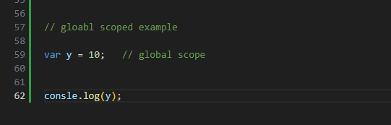

Block scoped:

* CURLEY bracket ky ander jo bi cheeze ho gi usy block scoped khy gy jasy ky example main dekhy

Example:

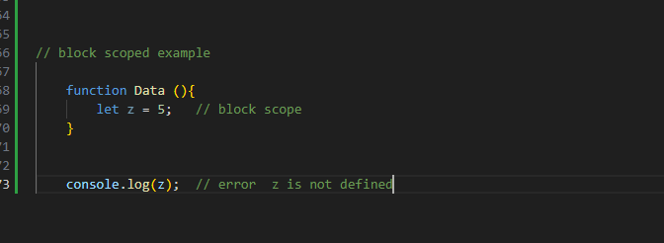

Reassignment, redeclaration:

* Variable ko declare karna or wapis sy same value assign karna hai var main laikin let main same value assign nahi karty.

Example:

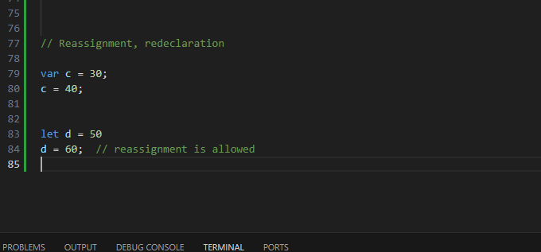

Temporal Dead Zone:

* Utna area jiss main js ko pata to hai variable exisist karta hai laikin wo iss ko acess nahi kar sakhta usy temporal dead zone khty hai

Example

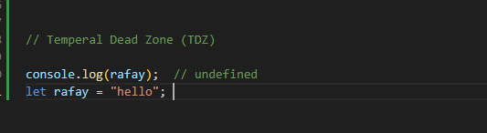

Hoisting impact per type:

Hoisting:

Hoisting ek variable ko jab js main banaty hai wo do hisso main tootha hai or us ka declare part upper chala jata hai or initiliazation part neeche rh jata hai.

Example:

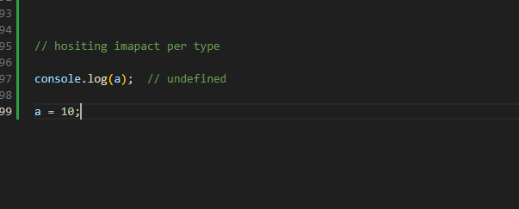

Practice chapter:

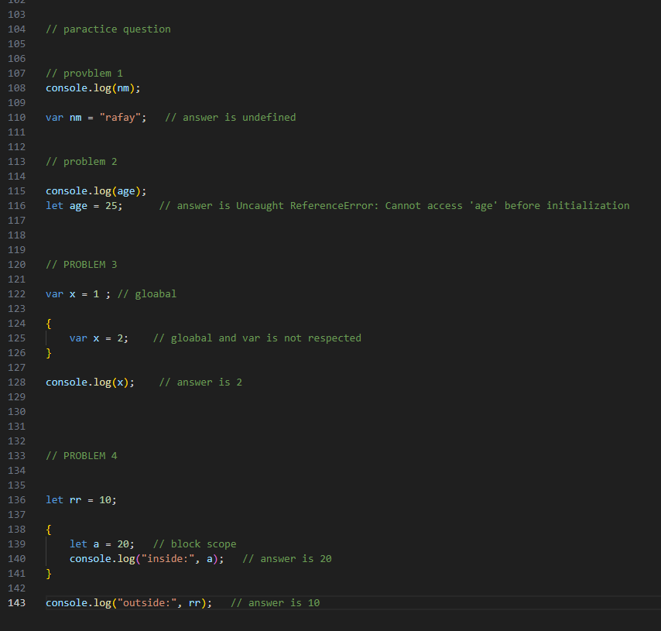

🧠 Chapter 2: Data Types + Type System.

Data Types:

* Data ka Type

Primitive:

* Assi sari value jin ko copy karny par tumhy aik real copy mil jay.

Example

* String, number, Boolean, null, undefined, symbol, bigint.

Symbol:

* Unique immutable value

Example:

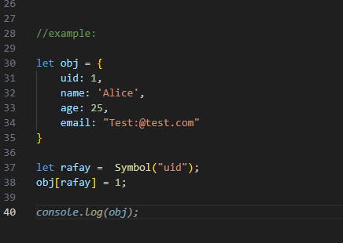

Bigint:

* Means ye ky jab main windows main sab sy bara number likhoon us ky sath add karny per add per end or number per n laga don to bgint ban jay ga

Example:

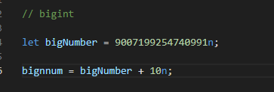

Reference:

* Inko copy karny par real copy nahi milay gi reference milay ga parent ka.

Example:

* Arrays, object, function.
* [], {},().

Array:

* Ham aik array ki value ko copy kar ky laikin us ka reference millay ga jasay.

Example:

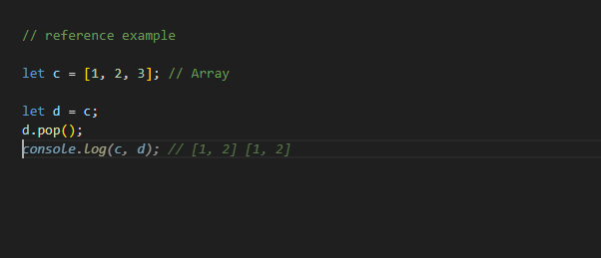

Object:

* Jasay hi ham aik object main changes karty hai sath hi sath wo change dono main ho jata hai ye reference value hai.

Example:

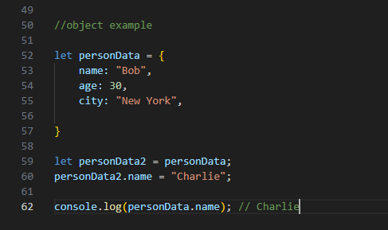

Dynamic Typing:

* Js main static typing nahi hai and yahan per hai dynamic typing jiss ka matlab hai ap data ko change kar sakhty hoo q ky yahan per dynamic data type hai.

Example:

* Baki language main static typing hai ap ny aik variable ko jo hai wo ap ny integer man liya hai bad main usy tum change nahi kar sakhty ho usy Boolean nahi bana sakhty.

Q ky javascript jo hai wo ap dynamic typing use karty hoo to usy change kar sakhty ho.

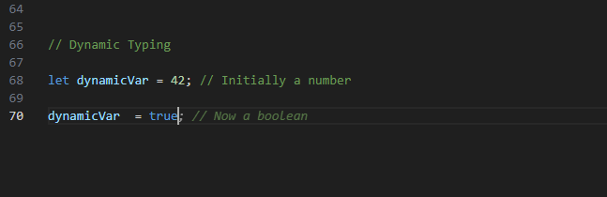

Types of Quriks:

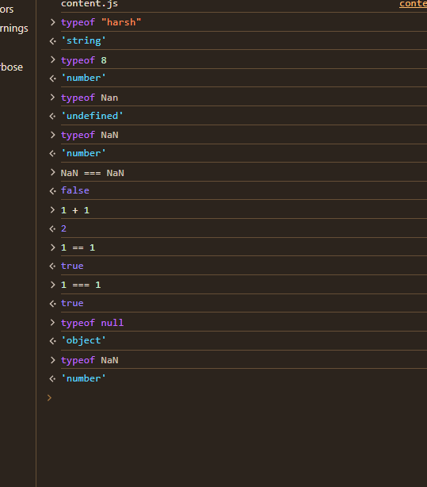

Type Coercion (== vs ===)

Truthy vs Falsy:

Type Coercion:

* Concept jis mein apka ek type automatically convert ho jay ga

Example:

Javascipt main mahmeatically isy join kar deta hai concatenate.

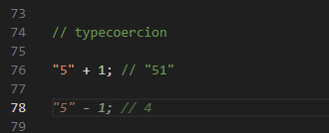

Truthy and Falsy:

* Asi sari value 0 false “”, null, undefined, NaN, Document.all to ye value false hai.
* Baki sari all value true

Paractice Question given answer:

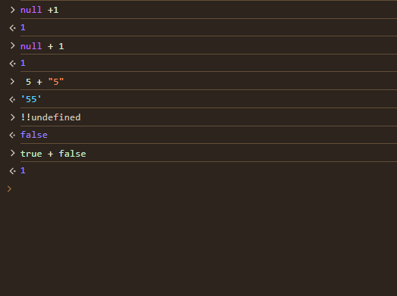

Confusion:

* Javascript is ko treat number ki tarhaan karta hai.

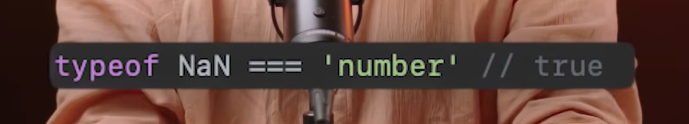

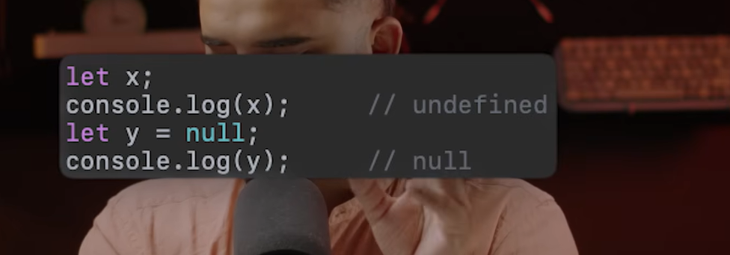

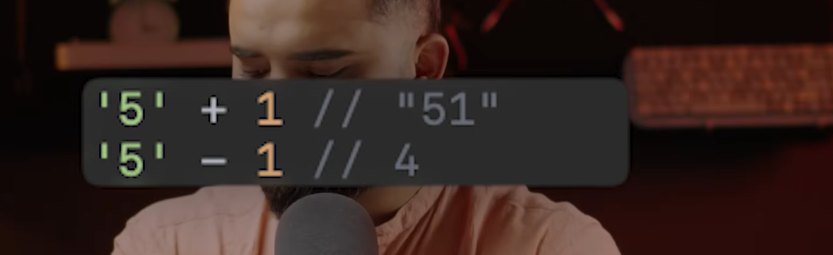

Operators:

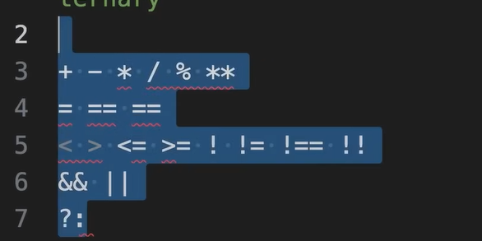

Addition:

* Means ky do number ko add karna or concatenate means number and string ko Milana add karna.

Example:

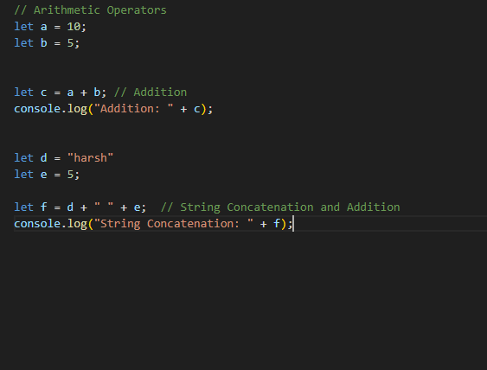

Subtract:

* Kssi bi value ko wo kam karna katna.

Example:

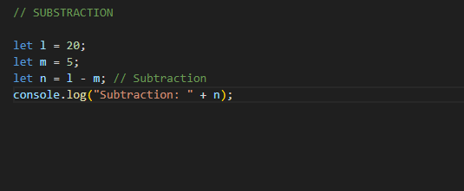

Divide:

* Kissi bi value ko divide karna hai us value sy jo answer ay wo likhna ha.

Example:

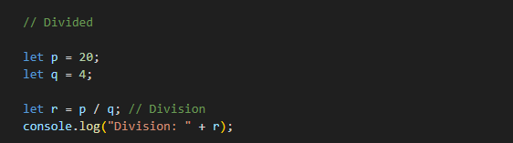

Multiplication:

* Do cheezo ko apas main multiply karna hai.

Example:

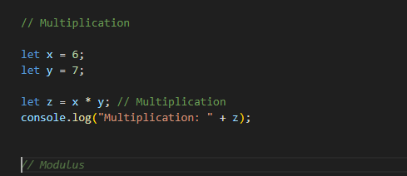

Modulus:

* Ye reminder deta hai.sara divided karna jo bach jay wo dena .

Example:

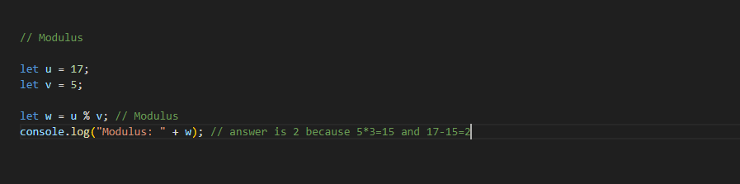

Exponential:

* Means ky power jasay 2 ki power 3.

Example:

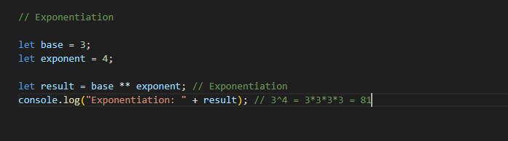

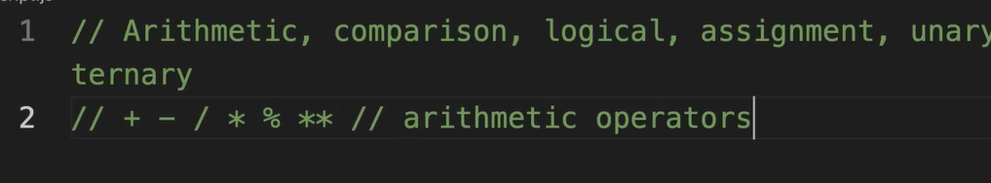

Comparison Operator:

Types:

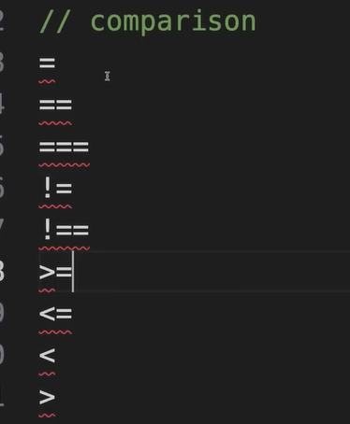

= :

* Value dalna equal ka matlab hota hai .

Example:

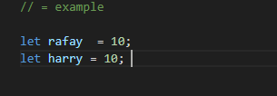

== not Strick comparison:

* Means ky left hand side baraber hai right hand side ky.

Example:

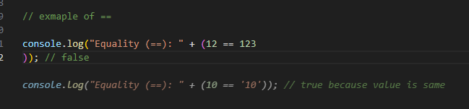

Problem:

* Problem ye hai ky 12 number hai or jo dusri side equal ka likha hai wo string main hai. Ye properly type ko check naho karta ye value same ko check karta hai.

Example:

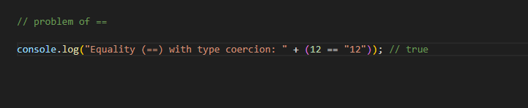

=== Strick Comparison:

* Means ye type or value dono cheezey check karta hai or answer bilkul tik ay ga:

Example:

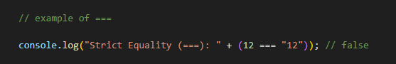

!= not Strick comparison:

* Means barber Nahi Hai

Example:

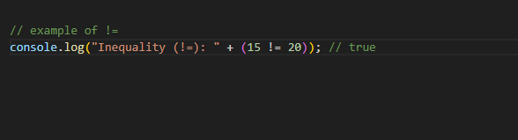

!== Strick comparison:

* Means check the value

Example:

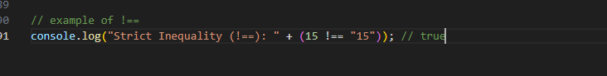

>:

* Means Ky big value.

Example:

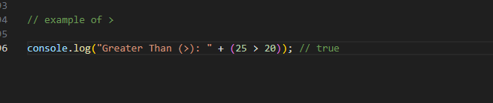

<:

* Less than

Example:

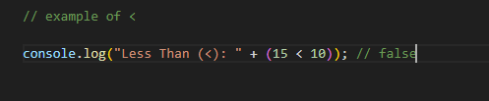

Assignment:

Types:

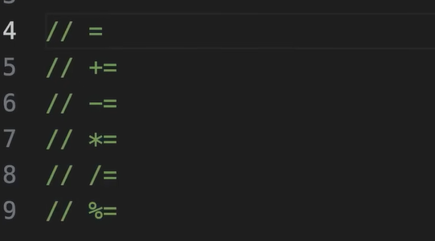

Example of these types:

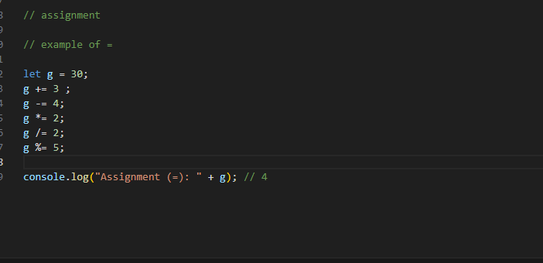

Logical Operator:

Types of Logical Operator are:

1. &&
2. ||
3. !

&&:

* Dono side per true hone Zaroori hai agr aik side bi false hoi to answer false ay ga.

Example:

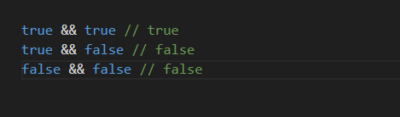

OR Operator ():

* Dono main sy koi aik side bi true mil gyi to true ay ga simple.

Example:

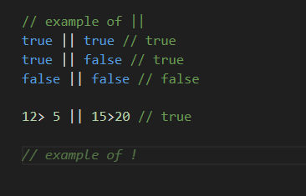

!!:

* Menas ky aik bar us ny true sy false kiya hai or wapis ulta kiya true karny ky liye.

Example:

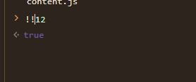

Unary Operator:

Types :

1. ++
2. –
3. +
4. –
5. type of
6. !

+:  
Example:

-:

Example:

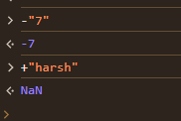

!:

We can check type truthy false.

Example:

Typeof:

We can check the type.

Example:

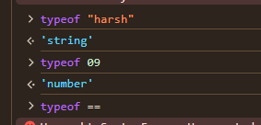

++ pre increment:

* Adding value.

Example:

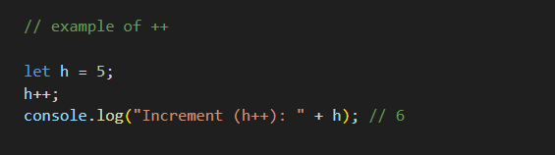

Ternary Operator:

Types

1. ?
2. :

How To Write:

simple condition ? value if true : value if false.

Example:

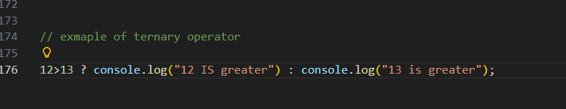

Queries:

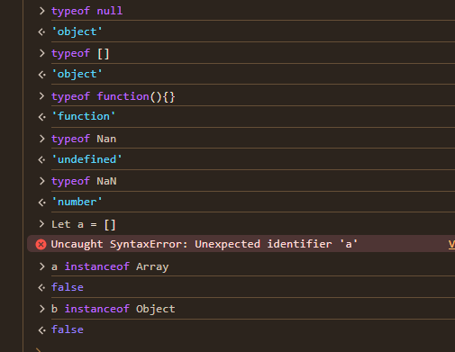

Paractice Question:

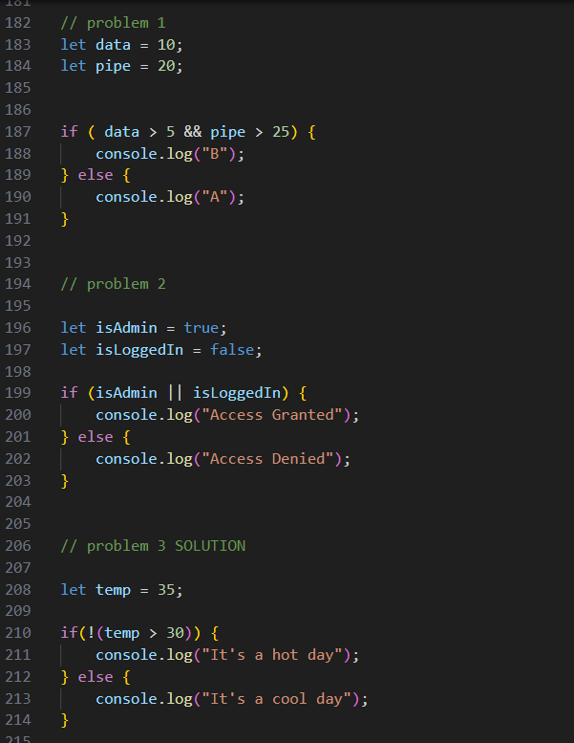

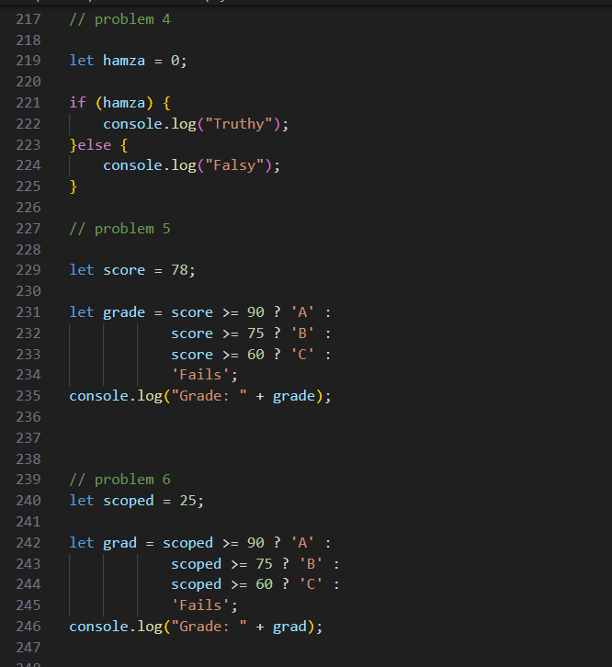

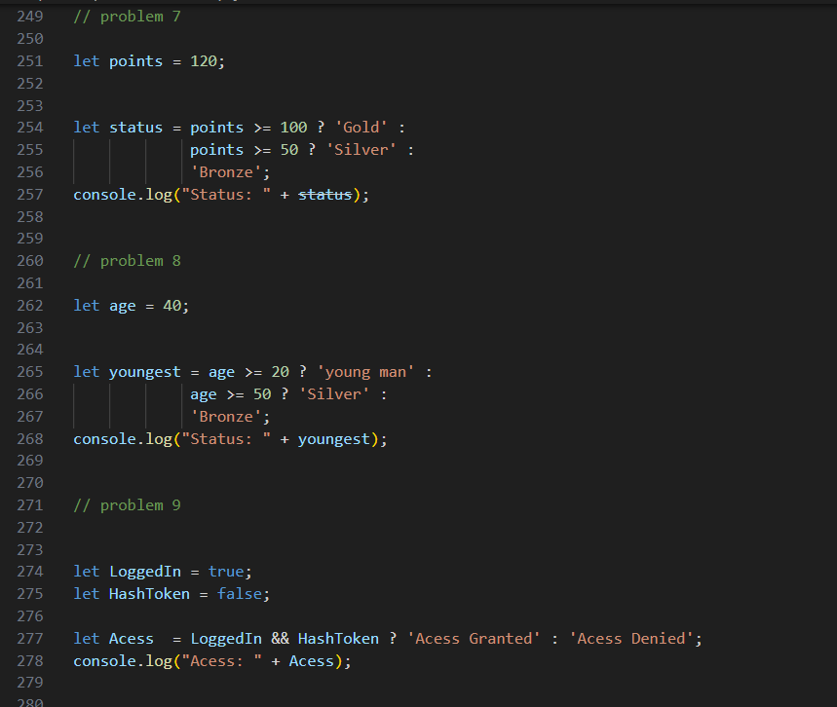

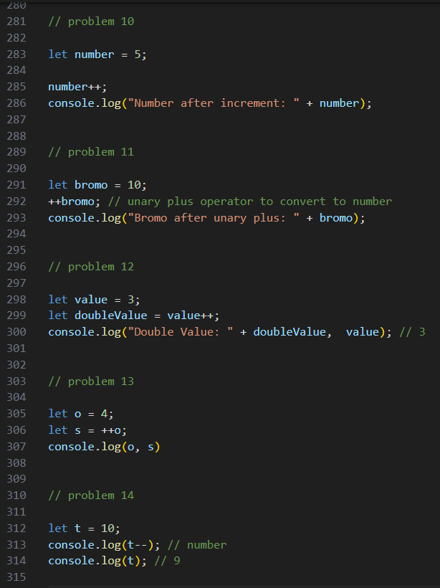

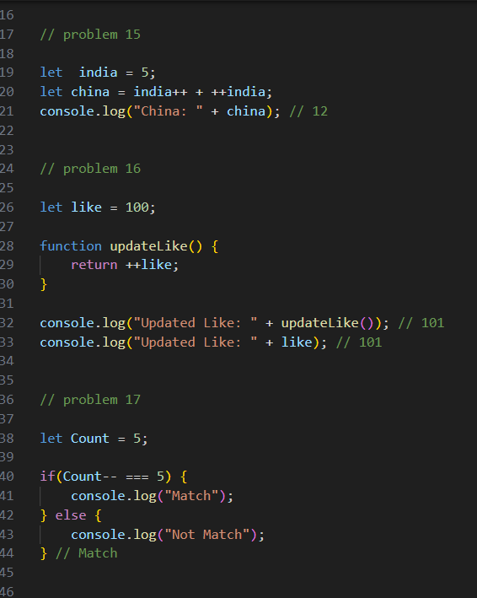

Confusion:

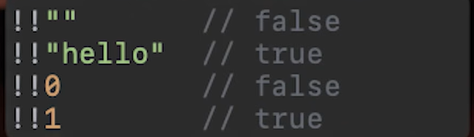

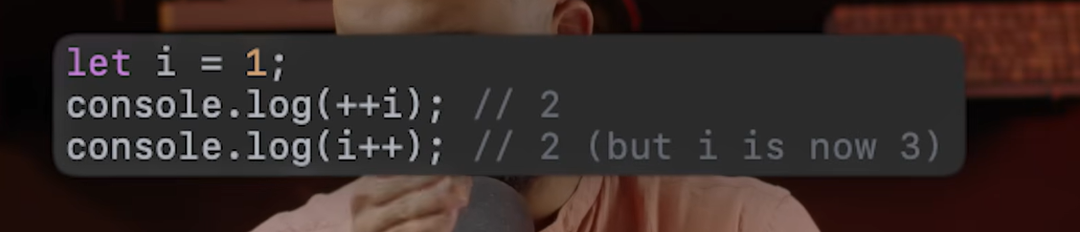

🧭 Chapter 4: Control Flow:

🧱 if, else if, else

1. Switch case.
2. Early return pattern.

2 Switch case:

* Is main ham log jo hai wo iss ki jon say cases matched karti hai us case ko nikalaty hai.

Example:

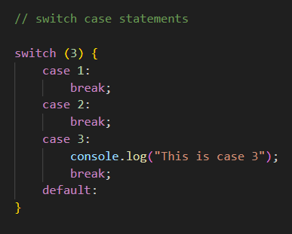

3 Early return Pattern:

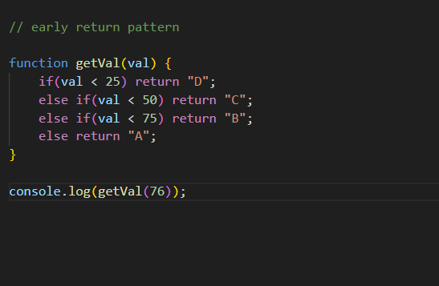

Practice Question:

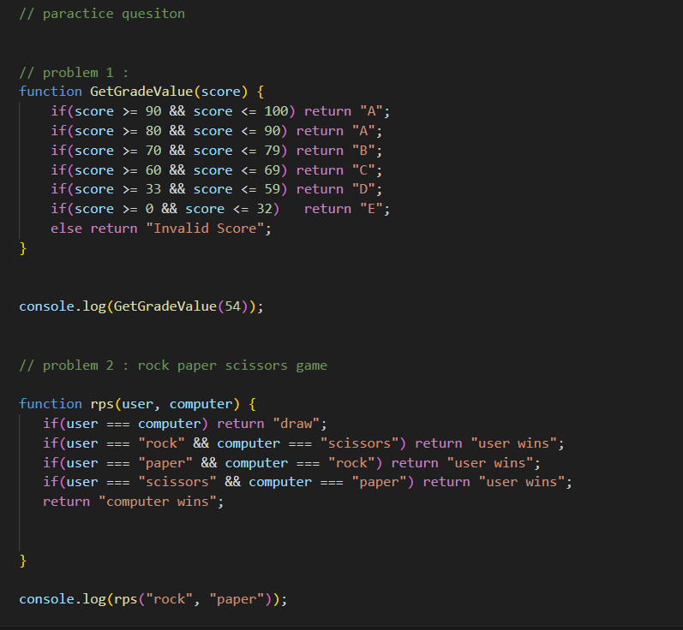

Common Confusion:

* Is main jo hai wo break nahi hai to seedha dusra case chal jay ga case hai error ay ga

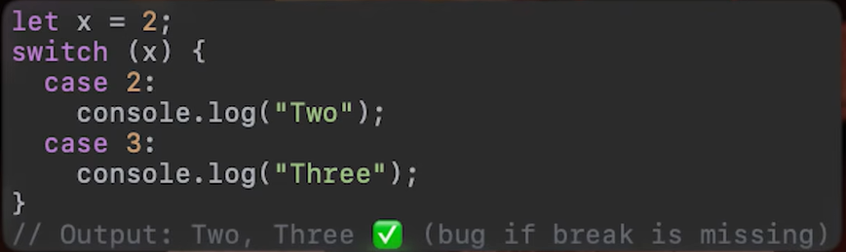

Paractice for me using chatgpt:

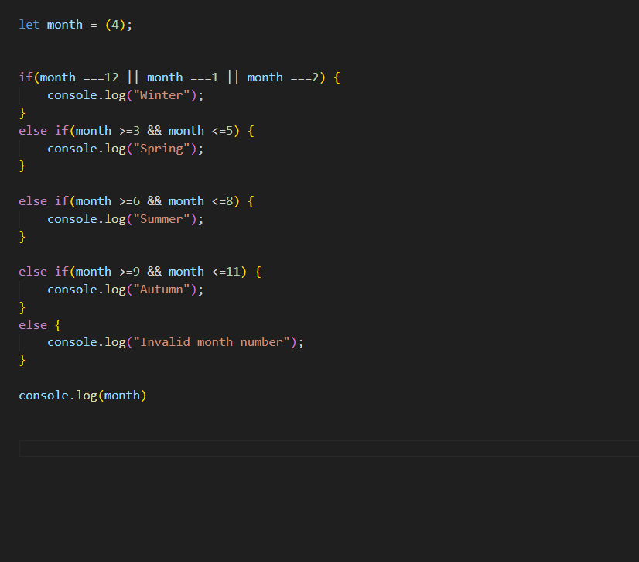

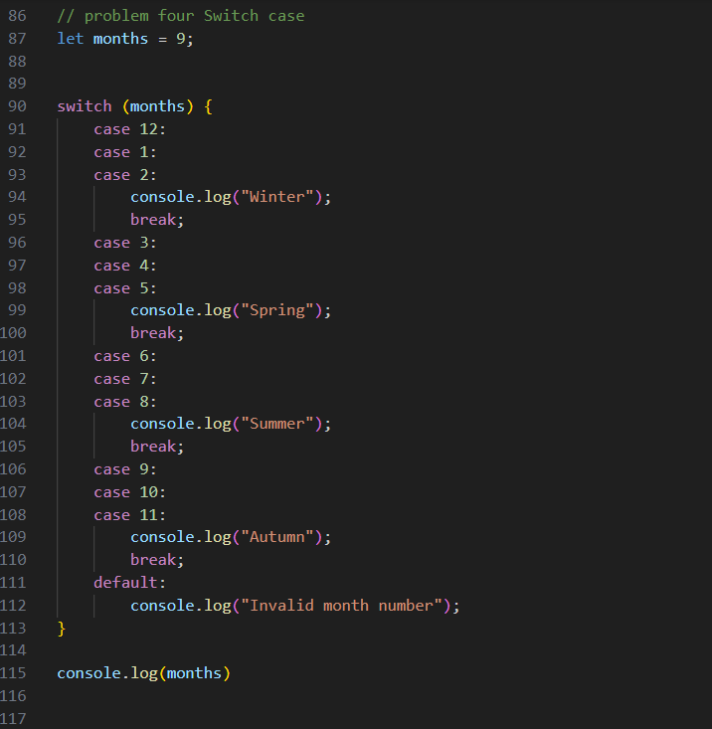

🔁 Chapter 5: Loops:

Loop:

* Computer main repeat karny ko loop khty hai .

Types:

1. For
2. While
3. Do-while
4. Forin
5. Forof
6. Foreach

For loop:

* Kaha se jana hai .
* Kahaan tak jana hai.
* Kaise jaana hai.

Example:

* Jab pata ho kasay jana hai pata hoo kahan tak jana hai for loop use ho ga.

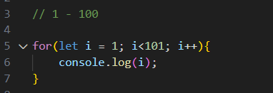

While Loop:

* Kaha se jaana hai.
* Kab rukna hai.
* Kaise jaana hai

Start pattern with While Loop:

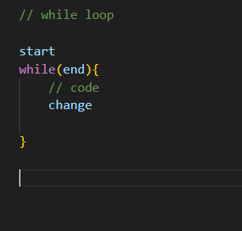

Example:

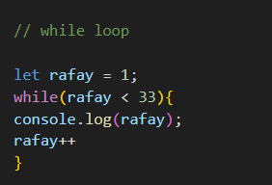

DoWhile:

* Do aik bar lazmi chalay ga beshak ap ki condition galat hi q na hoi ho.

How to Write

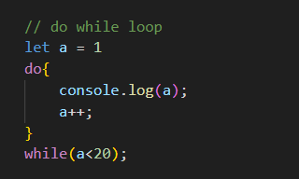

Example:

* Is main condition to galat hai laikin ye loop aik bar chaly ga

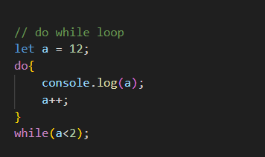

Break and Continue:

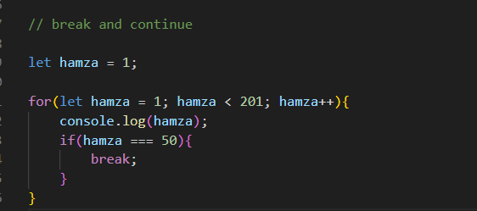

Continue:

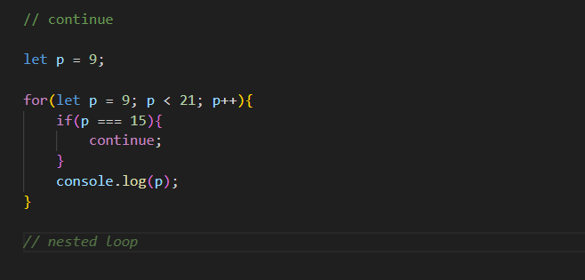

Practice Question and Answer:

Problem 1:

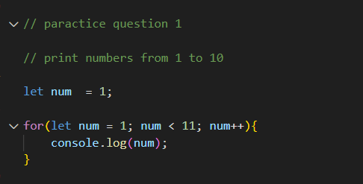

Problem 2:

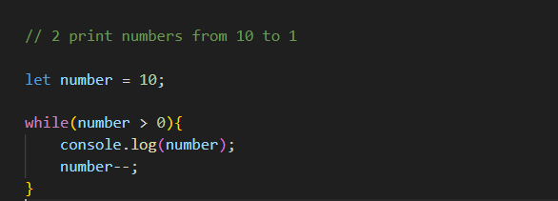

Problem 3:

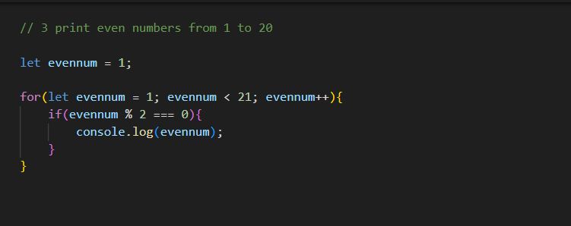

Problem 4:

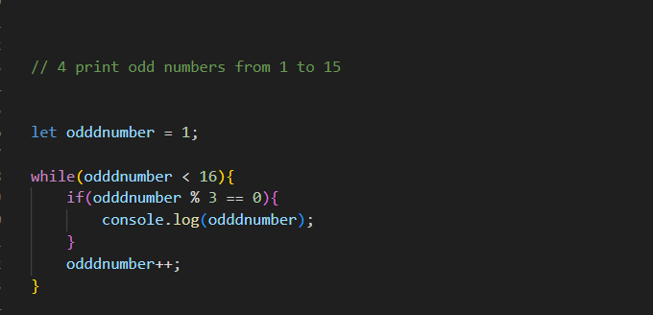

Problem 5:

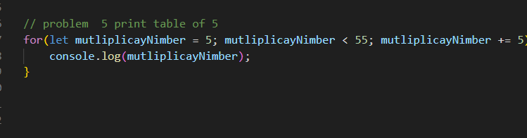

Problem 6:

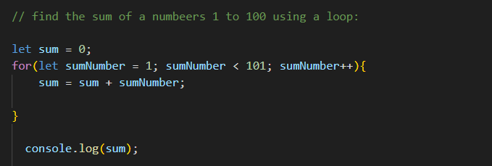

Problem 7:

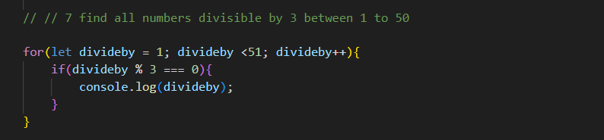

Problem 8:

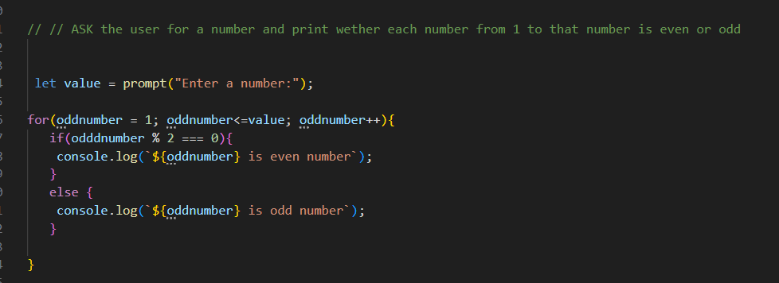

Problem 9:

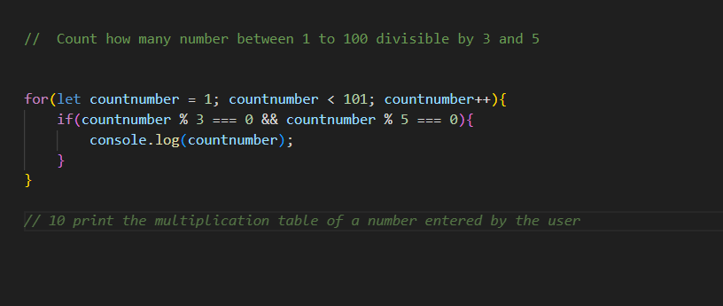

Break & Continue:  
Problem 10:

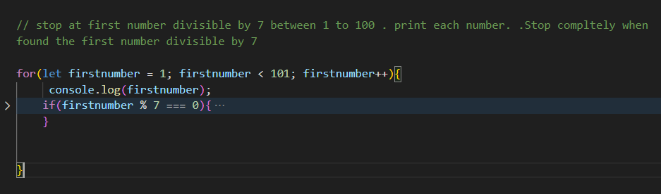

Problem 11:

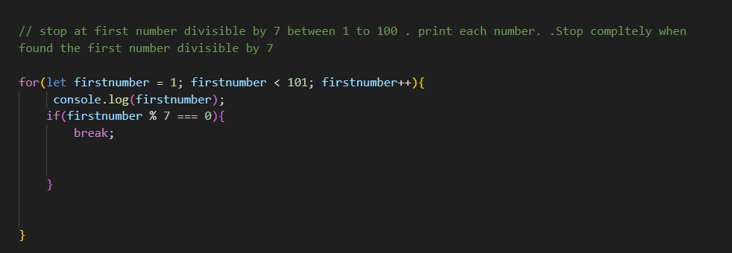

Problem 12:

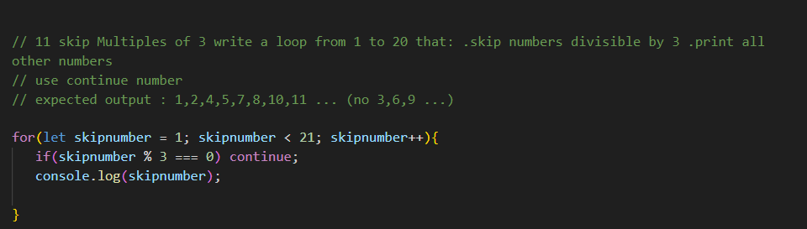

Problem 13:

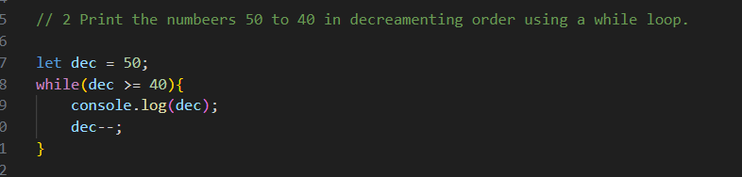

Problem 14:

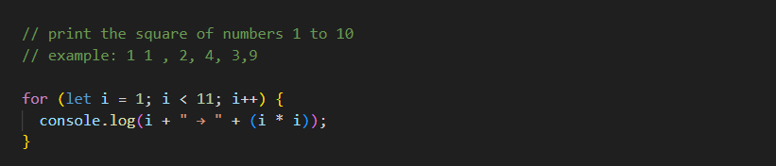

Problem 15:

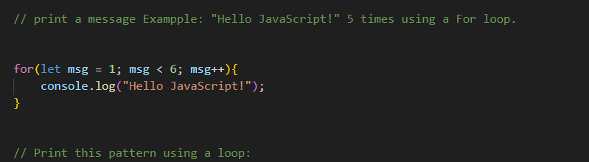Problem 16:

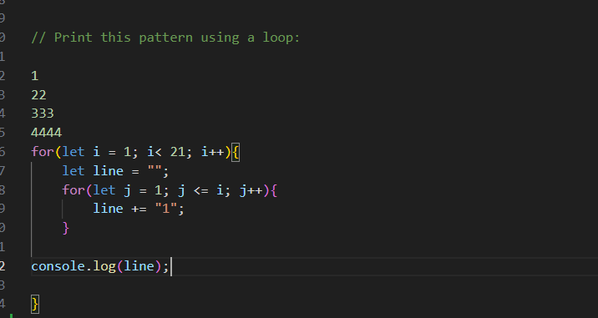

Problem 17:

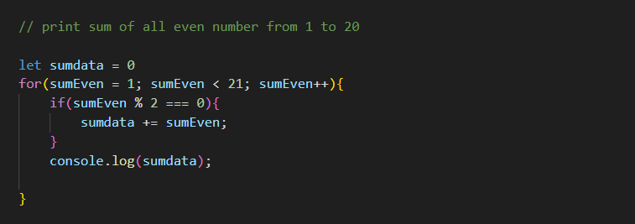

Problem 18:

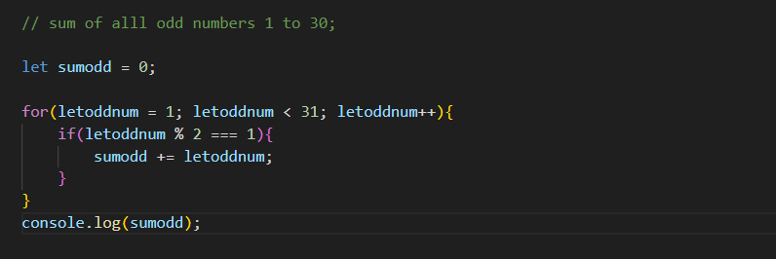

🧮Chapter 6: Functions

What is function? Why is function? And why we created function?

* Agr koi code tum ny likh diya ha wo foran chal jata hai

Why is Function?

* Function basically ham log use karty hai ky kissi button ky click per us ky hissay ka code run ho.

How we created a Function?

* Basically aik function key word round bracket and then koi bi name or cruley bracket khatam ho jay.

Example:

* Like this is main aik function banaya hai laikin us function main console lagya or function ko execute kia hai jiss main ye browser per ye do bar call ho jay ga.

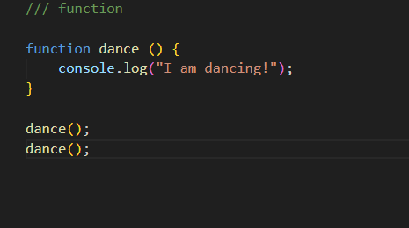

One more example how we can created function

* Is main basically aik variable crated kia hai or ab function ky sath name nahi likhy gy q ky ab aik variable main function hai iss wajha sy .

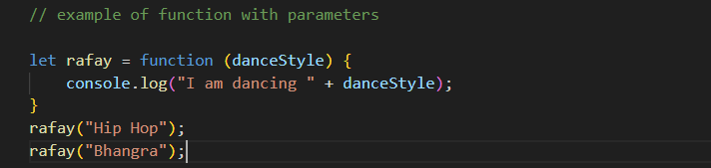

Function declaration and expression:

* Asy ham ny aik function create kiya to isy function declaration khty hai.

Example:

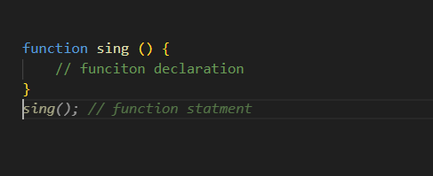

Function Expression:

* Ham ny aik variable main store koya isy expression khty hai .

Example:

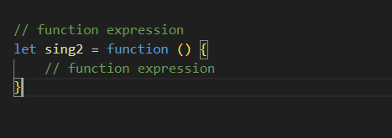

Arrow Function Fat Arrow Function:

* IS main jo hai aik variable main arrow function bana diya hai.

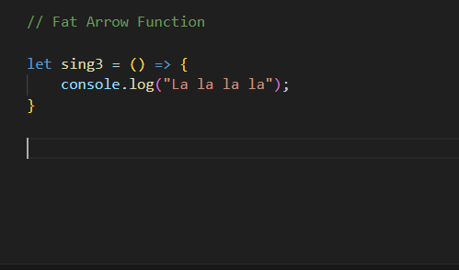

How is Created Fat Arrow Function.

Example:

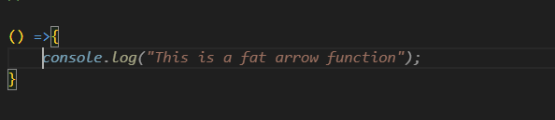

Parameter & Arguments:

* Is main basically aik function created kiya hai or us main aik parameter diya hai or neche call kar us ki value function ky ander sy change kar li hai.jab bi console lagaya value change ki.

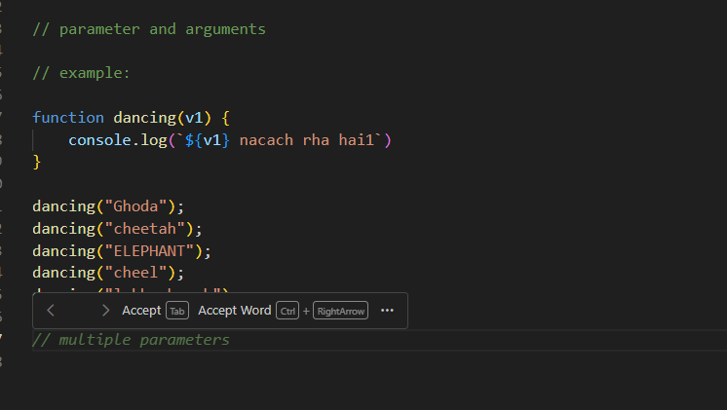

Example:

* is main ham ny basically aik function created kiya hai or us main ham ny 2 parameter liye hai or un main aik console main add ky parmeter add kiye hai takay wo add ho sakhy or finally us function ko call kiy or 2 parameter ki value di hai.

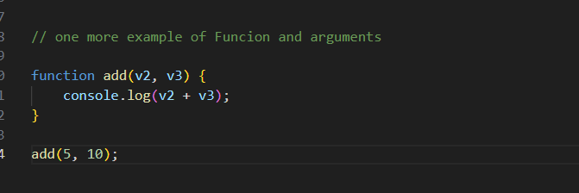

One More Example:

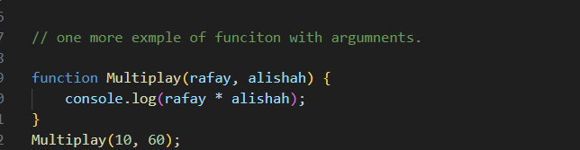

One more Example:

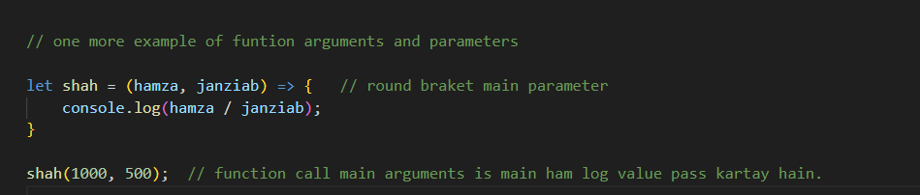

Default, rest and Spread Parameter:

* dekho ap ny aik function create kiya hai or parameter main value di hai or us function ky ander console main value mangi or function call kiya laikin value ap ny call kar bhaji hi nahi to us case amin javascript amin ye is ki by default undefined, undefined ay gi .

Example

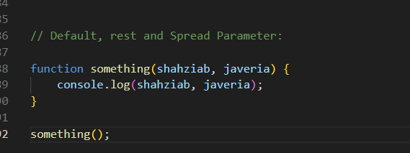

One more example:

* is main basically 2 parameter main value gi hai laikin us ki value nahi di hai or add ka operation hai or javascript main bydefault undefined + undefined NAN Not a Number.

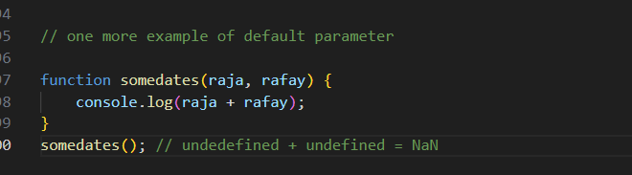

One more Example:

* is main jo hai ham parameter ky ander value dy sakhty hai agr neche function main na di ho to tab us halat main.

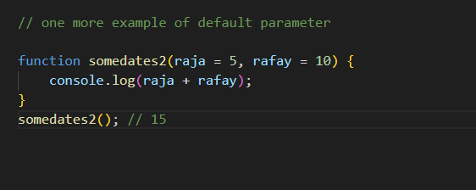

Rest and Spread Operator:

Jab argument kai sarre ho to humein utne hi parameter hi banany hoon gy is sy bachny ky liye ham rest and spread ka operator … khty hai

1. agr … function ky parameter main lagay to wo rest operator .
2. agr wo arrays and object main lagay to spread operator lagay ga .

Example:

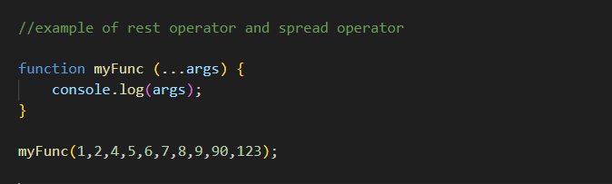

Return value and early return

* jahan sy ay hoo wahi sy daal denge

Example:

Is ki story ye hai ky jab ham log aik function created kartay ha tab ab ny line number 2 per banaya or line number 500 per call kiya return main kuch bi likha tab wo jo hai wo aik function chala or value return ki hai .

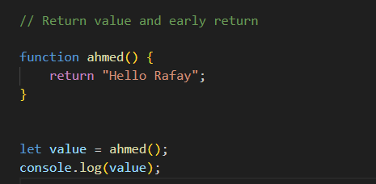

Example:

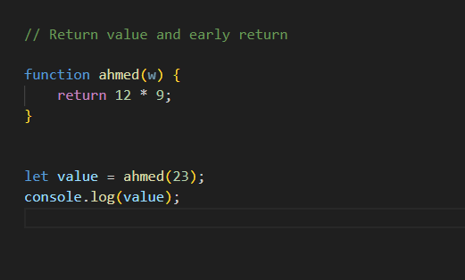

First Class Function Concept:

Asy function jin ko value ki tarhaan treat kar sakhty hai.

Example:

Is main jo hai puri tarhaan function ko aik value ki tarhaan use ho sakhty hai jasay iss example main batay hai

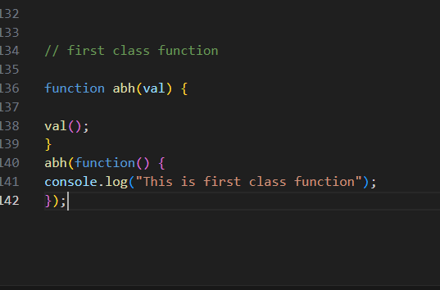

High Oder Components:

* Wo function hota hai jo return karay function ya pher accept karay function apny parameter main.

Example:

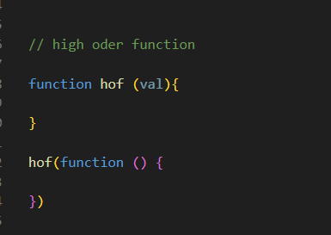

Example:

* Ab is example main aik function banaya or return kia aik function or neche call ki hai aik function usy high oder function.

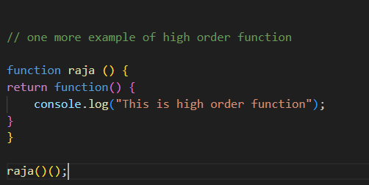

Pure VS Impure Function:

Pure

Asa function jo bhir ki value ko na badlay wo pure function.

Example:

Ab dekhoo ye apni value ko badal nahi rha pure function

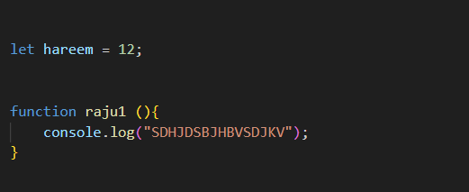

Impure:

Asa Function jo bhir ki value ko badlay impure function khty hai

Example:

Ab dekhoo is main jo ha wo variable main ham ny aik value save ki thi laikin funcitin main us ny value updated ki ha busy impure funcutin khty hai .

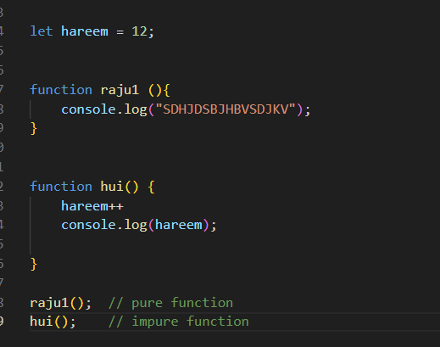

Closure & Lexical scoping

Aik function jo return karay aik or function return honey wala function hamesha use karay ga parent function ka koi variable

Example:  
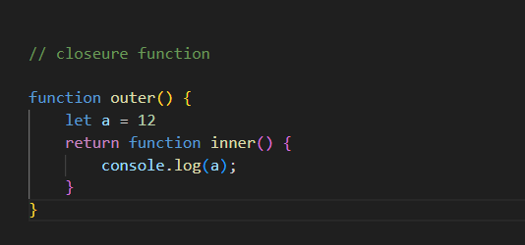

Lexical scoping:

Is example main ye bat ki gyi hai ky ghi aik function hai to b ko ham is function ky ander kahi bi aces skar sakhty hai. Dusir bat jkl function main c ko ham is ky ander aces skar sakhty hai . mno walay function main ham log d ko aces skar sakthy hai

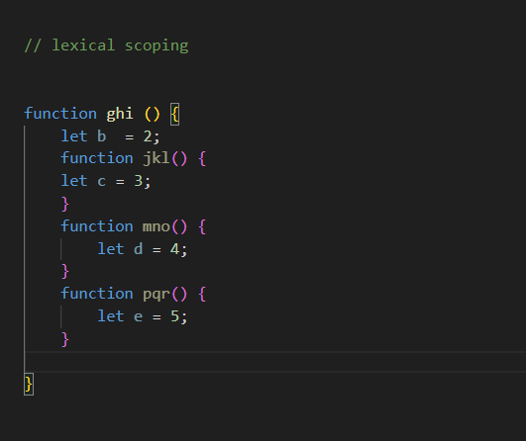

IFFE:

Immediately invoke

Example

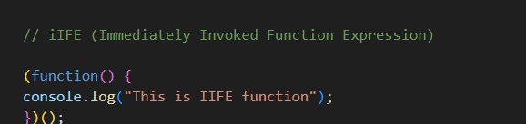

Hoisting:

Function main ham usy hoist kar sakhty hai or varible ky ander function main error ata hai

Example:

Is tarhan main error ata hai ye aik varible ky ander function main hoist nahi hota.

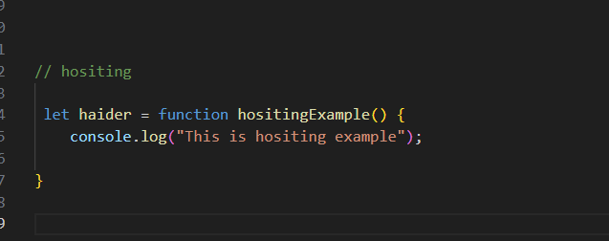



Function statement main hoisting hoti hai

Example:

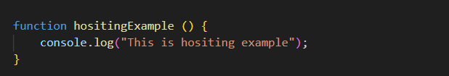

Practice Question:

Problem 1:

Function main hositing hoti hai jab ky function ky expression main nahi hoti error ata hai Uncaught ReferenceError: Cannot access 'alisha' before initialization

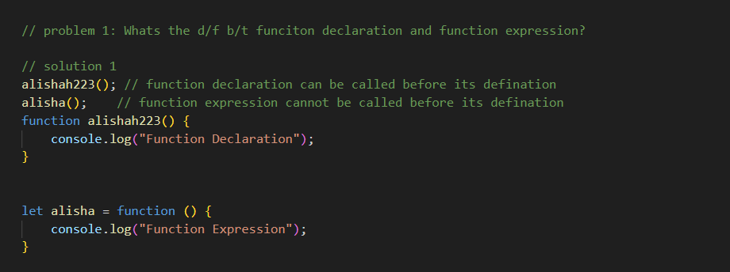

Problem 2:

Function main hoisting hoti hai.

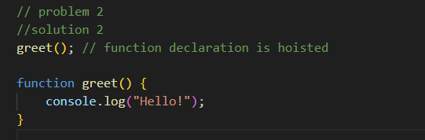

Problem 3:

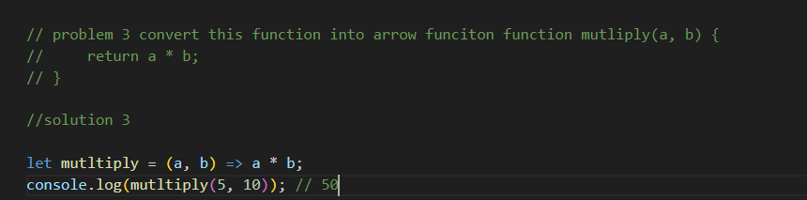

Problem 4:

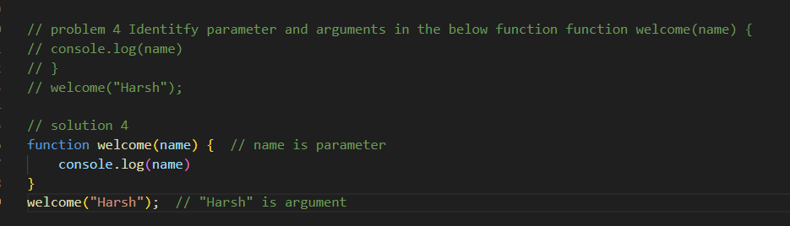

Problem 5:

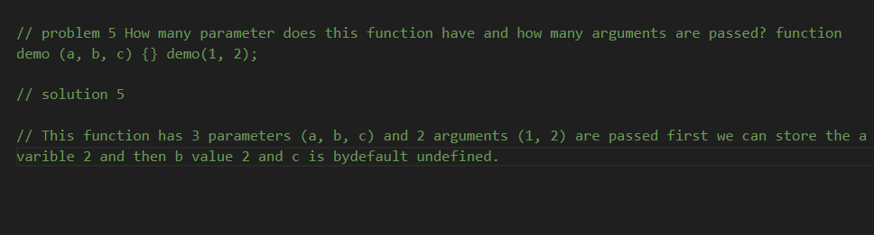

Problem 6:

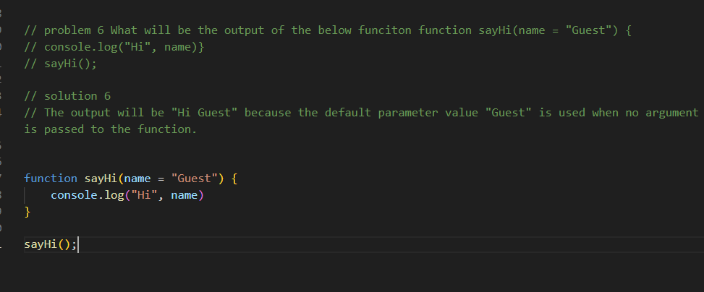

Problem 7:

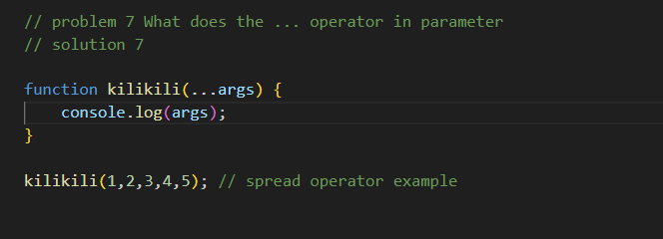

Problem 8:

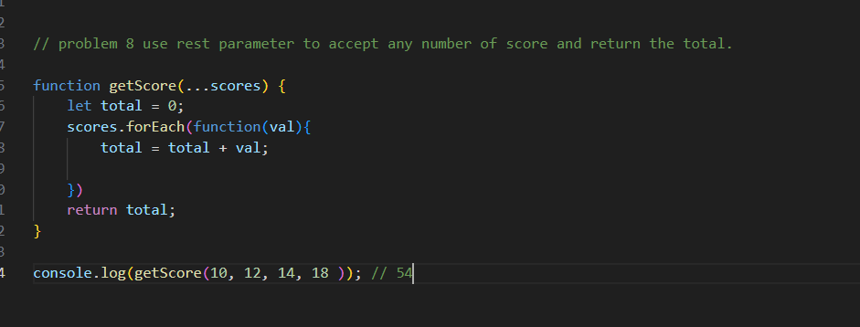

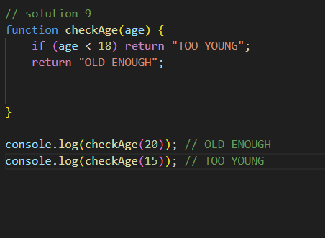

Problem 10:

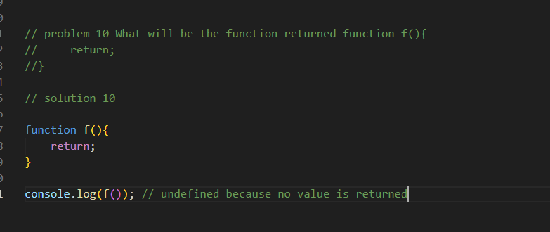

Problem 11:

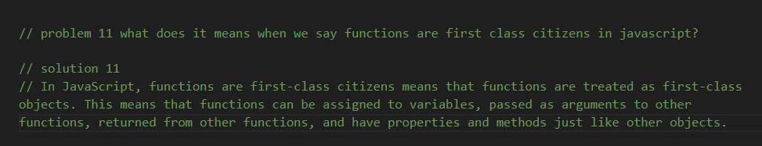

Problem 12:

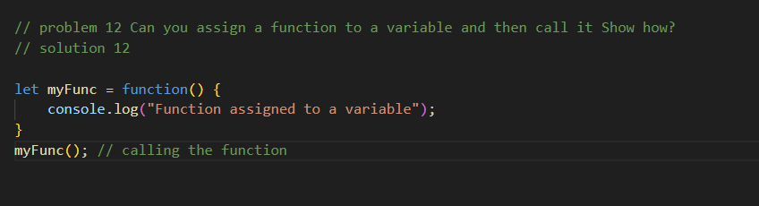

Problem 13:

HIGH ODER COMPONENT

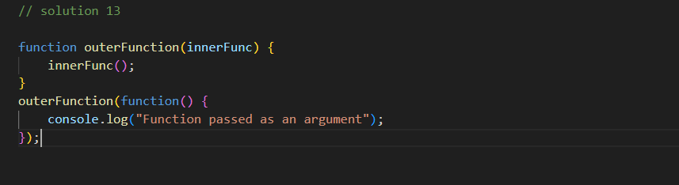

Problem 14:

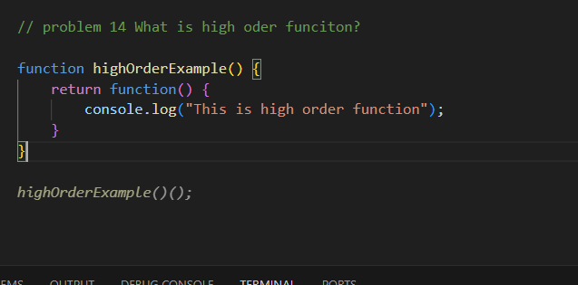

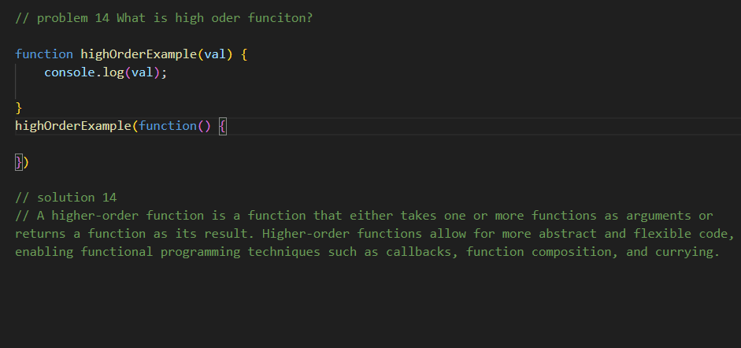

Problem 15:

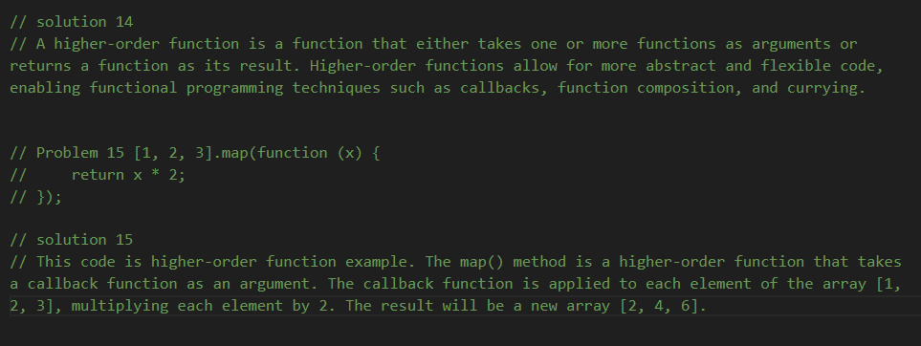

Problem 16:

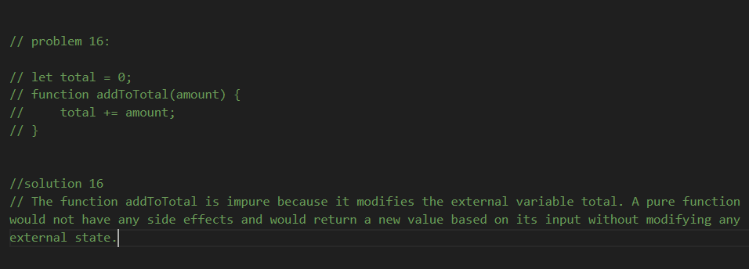

Problem 17:

Asa function jo return aik function kar rha hoon or function k ander value return kar rha hoo.

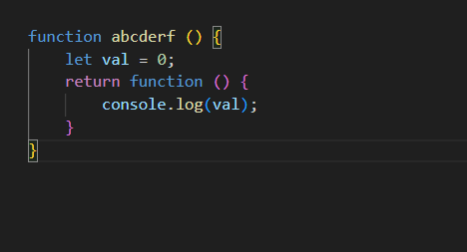

Problem 18:

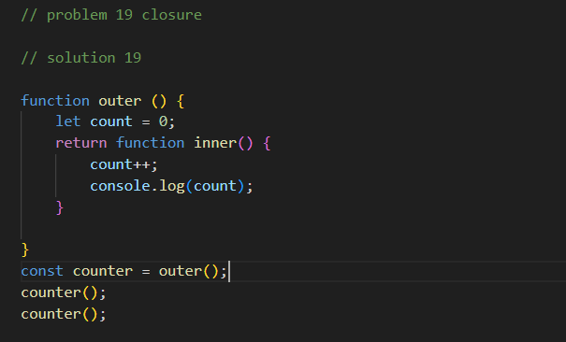

Practice Question:

Problem 1 :

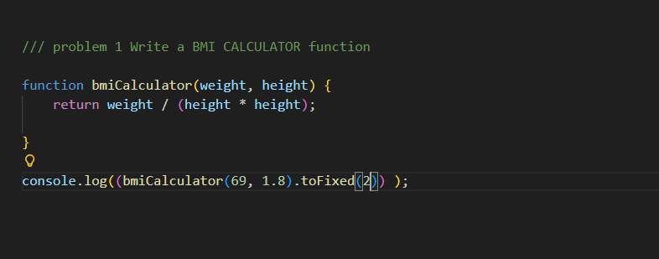

Problem 2 :

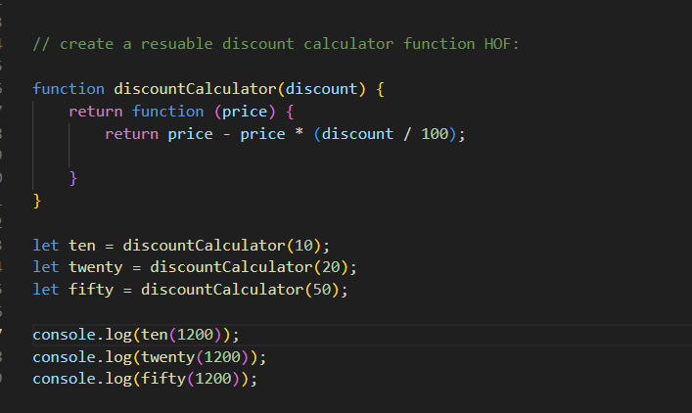

Problem 3:

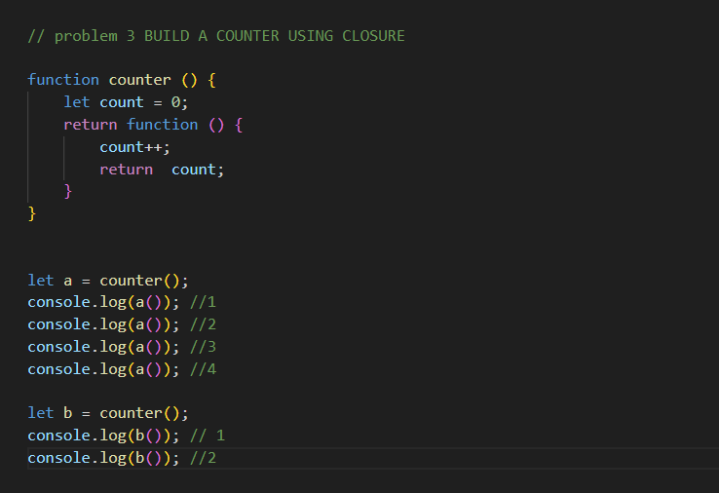

Problem 4:

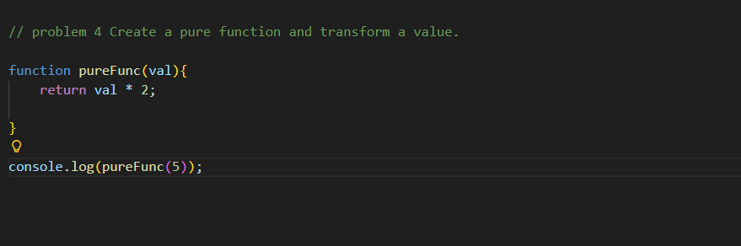

Problem 5:

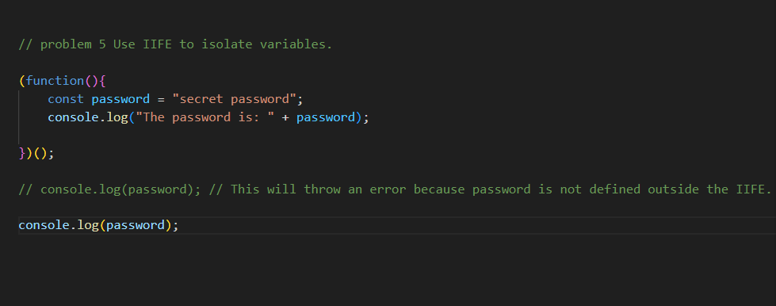

Problem 1 and 2 chat gpt

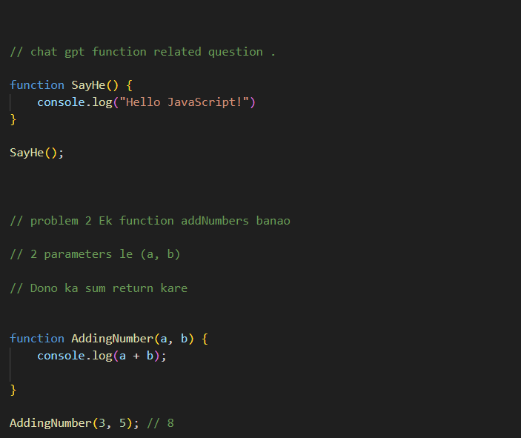

Problem 3:

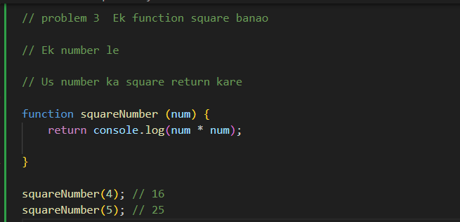

Problem 4:

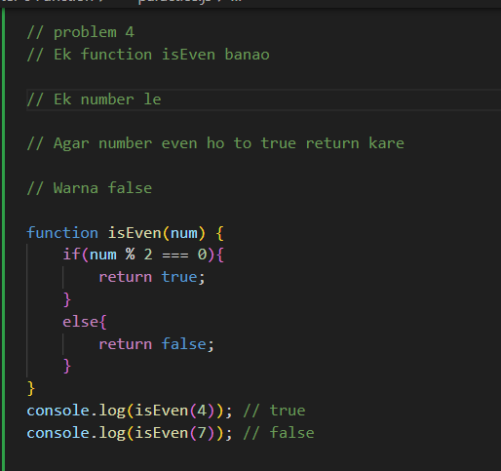

Problem 5:

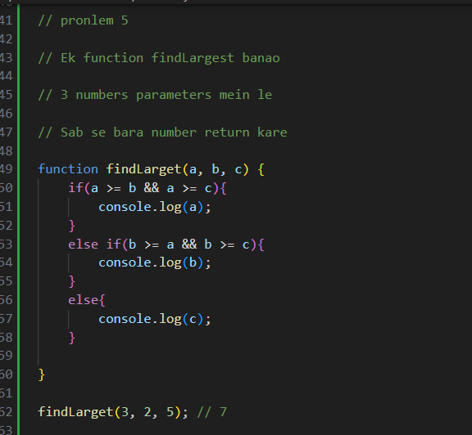

Problem 6:

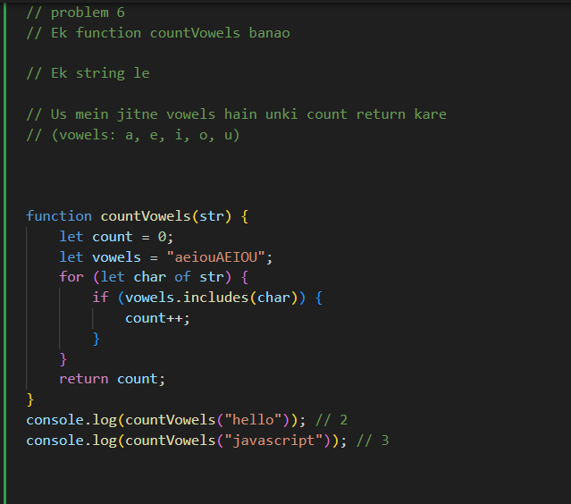

Problem 7:

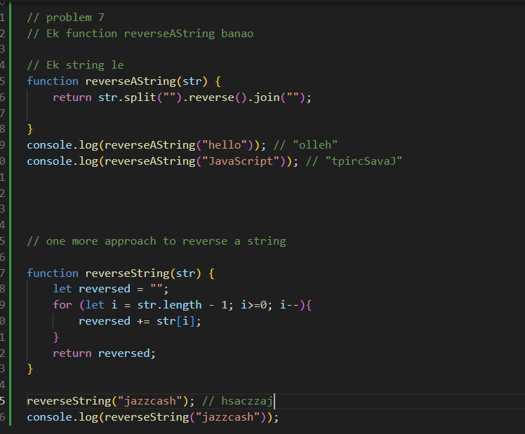

Chapter 7 Arrays:

Arrays How we created?

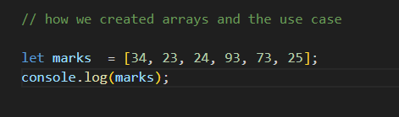

Example:

34 Hamesha 0 index per ho ga or 23 one index per and 24 two index per 93 three index per 73 fourth index per and 25 fifth index per.

Modify Arrays:

Means ky arrays main 3 index per koi value add karny ko modify khty ha

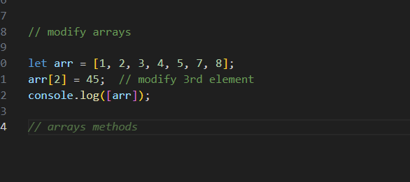

Arrays Methods: push, pop, shift, unshift, splice, slice, reverse, sort.

Push Method:

Main ham log aik value arrays ky end per add hoti hai

Example:

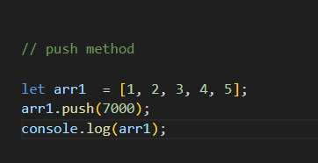

Pop Method:

Is main sy last value arrays sy remove ho jati hai.

Example:

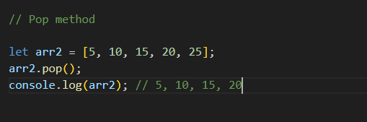

Shift Method:

Arrays ki first value ko remove kar dy ga .

Example:

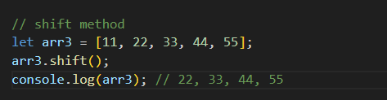

Unshift Method:

Array ki suru main value ko add karta hai.

Example:

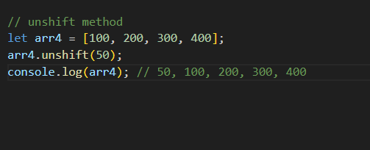

Splice Method:

Ye arrays ki center sy value ko remove karta hai.

Example:

Is example main splice method 2 index ki value or sath hi sath 2 value remove karni hai to splice method lagaya ha

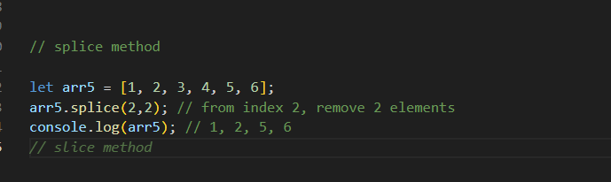

Slice:

Slice main new array change nahi ho ga balky new arrays main add ye slice method 0 index sy 3 index tak jitni value hai wo alag ho jay gi.

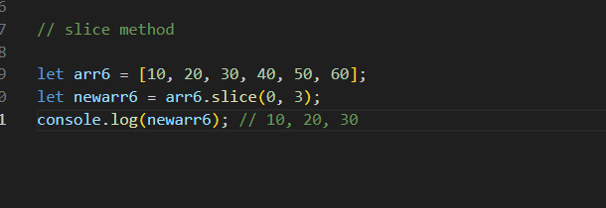

Reverse Method:

Main array ko reverse kar deta hai

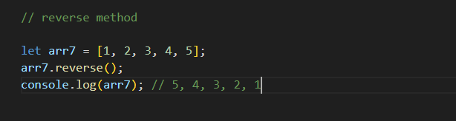

Sort:

Sort hamesha aik function leta hai syntax ha jiss main ham asendeing order main value or desending order main value .

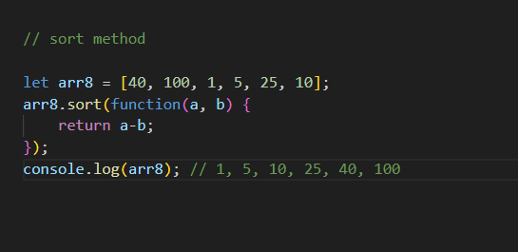

For Each Loop:

Array ky ander aik function chalta hai or har us array ki value ko print karta hai.

Example:

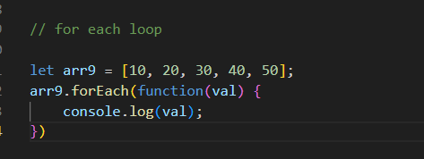

Map:

Map sirf tab use karna hai jab apko aik new array banana pechle array ky dara ke basis par.

Map dekhty sath mind main ek blank array bana loo.

Example:

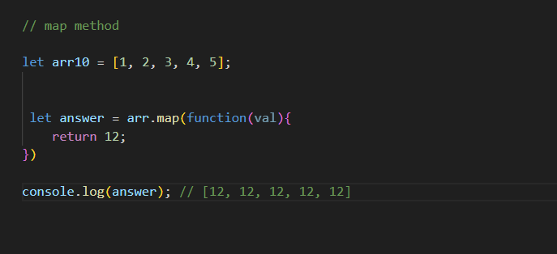

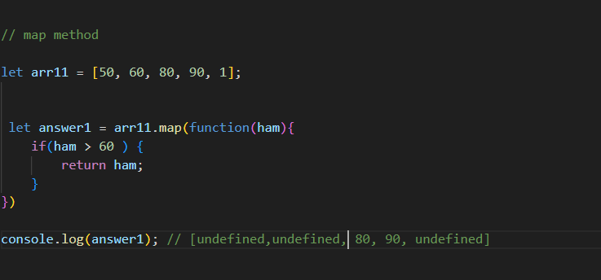

Jab bi apko aisa case dekh jay jahan par ek array se new array banay ga and wo new array kuch value ko rhky ga .

Filter:

Bi aik new array banata hai laikin wo ya true main new arrays main value jati hai or false main nahi jati

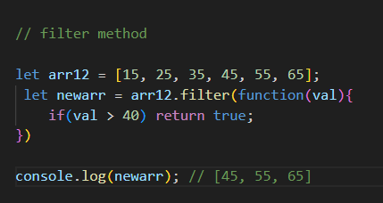

Reduced Method:

Is main jo hai jab ham aik array main sab ko jor kar aik number lay usy reduced method khty hai.

Example:

Accumulator bar bar apni value ko yaad rhkta hai.jasay 0 acumulator ki value hai jab bi 0 + value array ki 5 hai or ye 5 return ho kar accumulator ky pass gya to accumulator ki value add hony ky bad updated ho jay gi

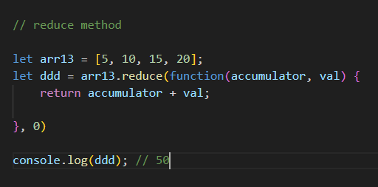

Find:

Ap ki array main sy jo bi phela banda jo bi ap ki condition ko statisfy karay ga wo banda execute ho jay ga.

Example:

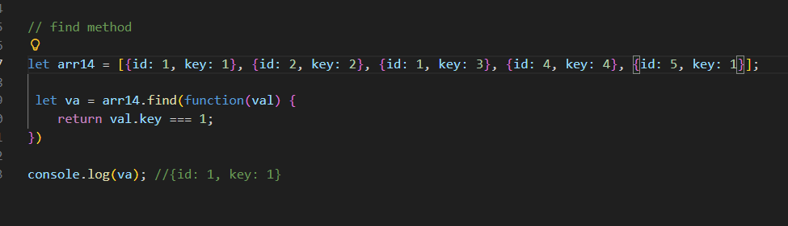

Some Method:

Is main basically jab hamari array main aik scores hai agr us condition sy zaidha marks hoye to return true ho jay ga.

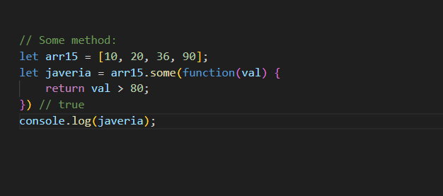

Every Method:

Every method main har aik array true honi chahiye agr false hoi to wo false return ho ga warna true.

Example:

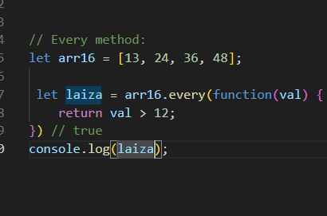

Destructing and spread operator:

Destructing:

Example:

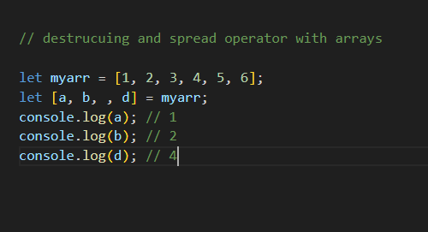

Spread operator:

… ka matlab hai array ki sari value utaoo or bekhar do new array

Example:

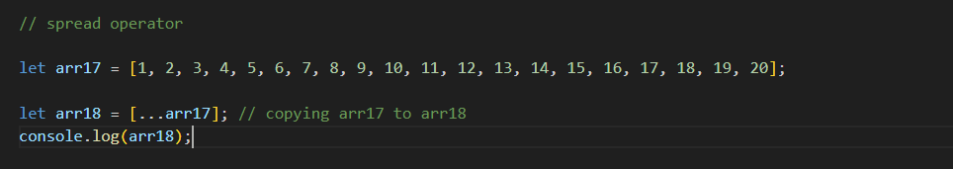

Problem 1:

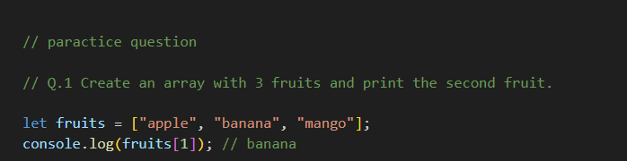

Problem 2 :

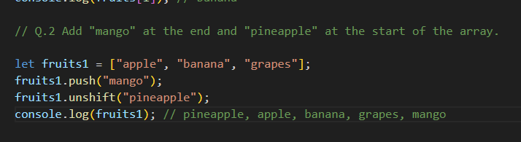

Problem 3:

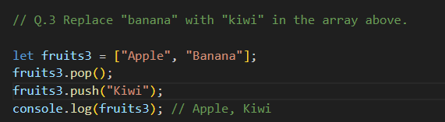

Problem 4:

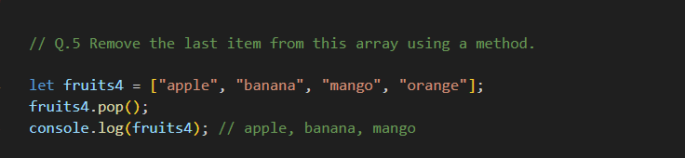

Problem 5:

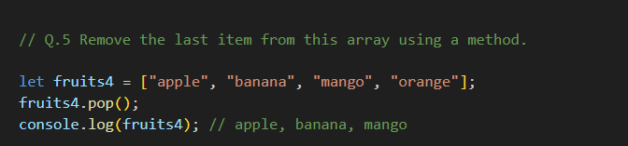

Problem 6:

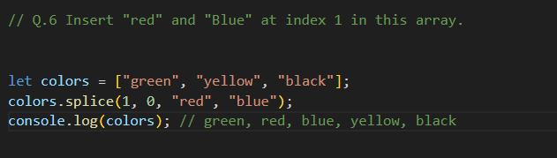

Problem 7:

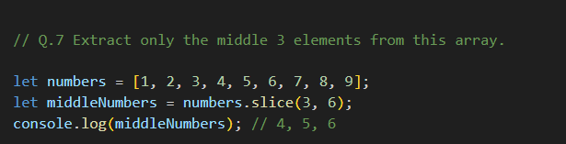

Problem 8:

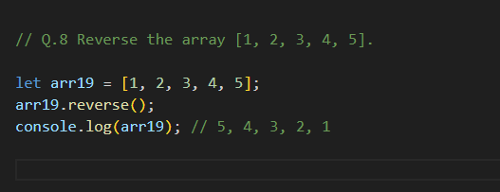

Problem 9:

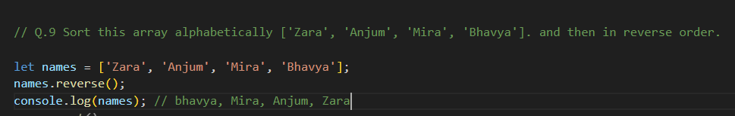

Problem 10:

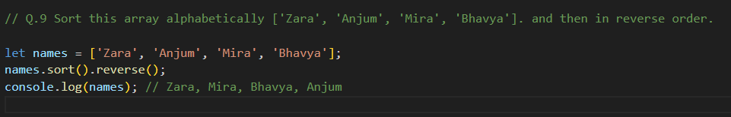

Problem 11:

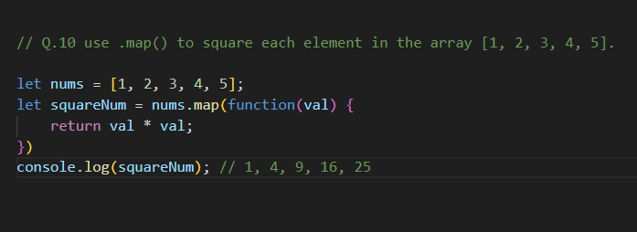

Problem12:

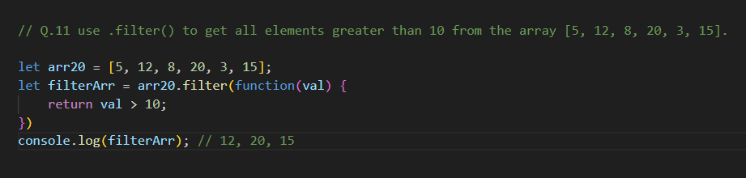

Problem 13:

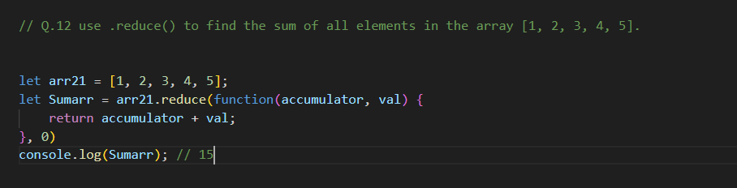

Problem 14:

Find main jahan sy match hota hai wahan sy hi print karta hai or koi value nahi dekhta .

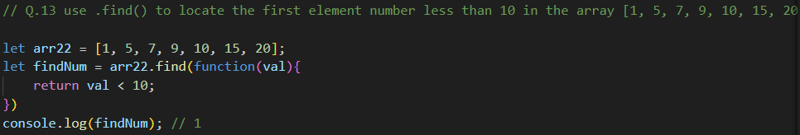

Problem 15:

Jahan sy bi condition match ho gi wahi sy wohi print kar ky execute ho jay ga array ki value main.

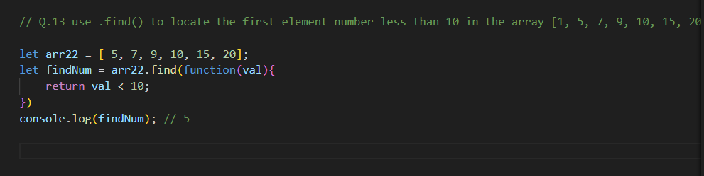

Problem 16:

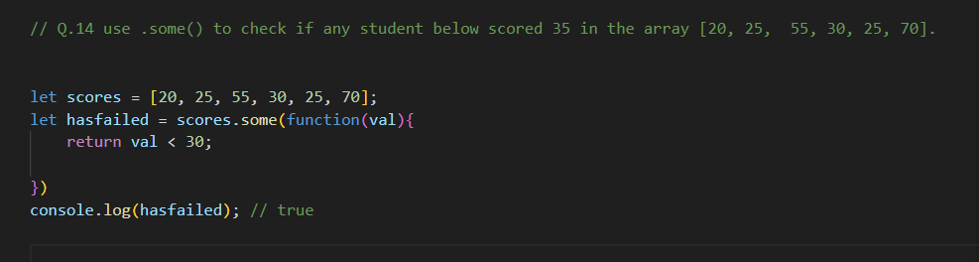

Problem 17:

Is case every method main saray case even hon gy true warna false

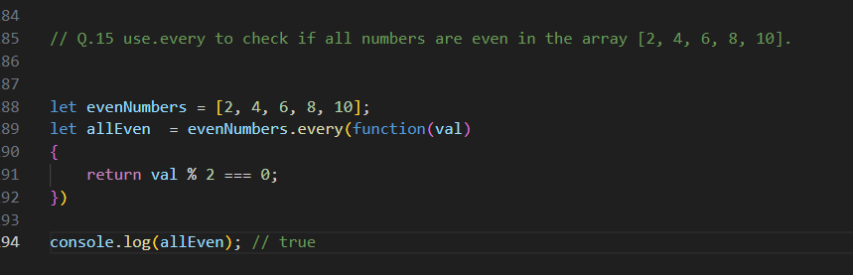

False condition every method.

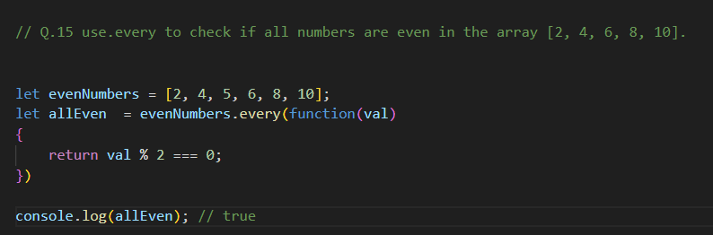

Problem 18:

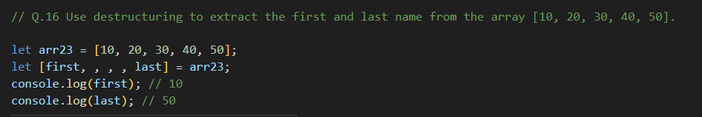

Problem 19:

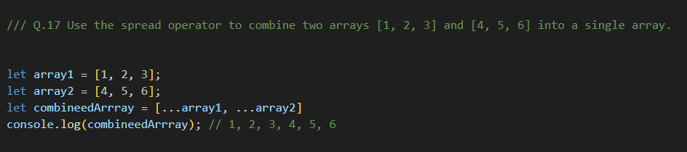

Problem 20:

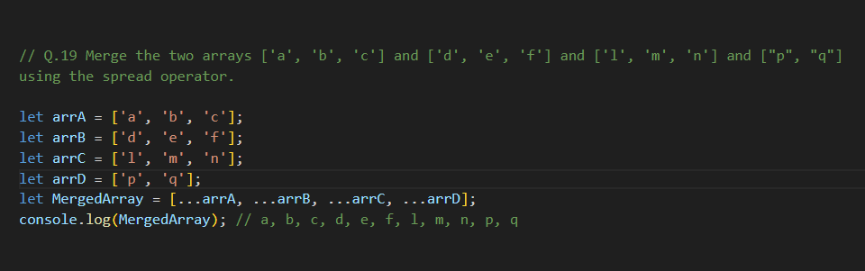

Problem 21:

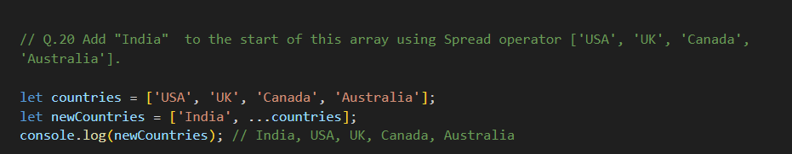

Problem 22:

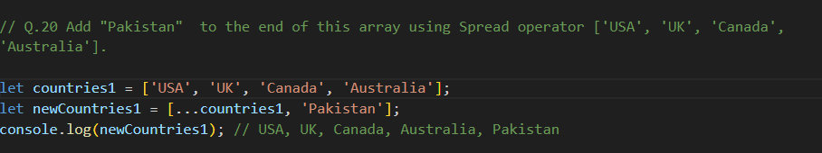

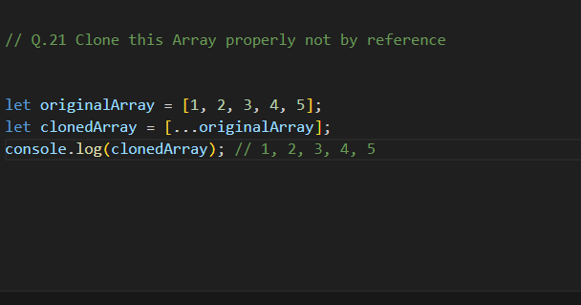

Common Confusion:

Slice Vs Splice

Splice:

Value ko remove kar deta hai original array main sy

Slice:

Ap ko jo hai wo array main sy value nikal ky deta hai .

Map Vs Foreach:

Map:

Main ham kuch na kuch array sy return karay gy .

Foreach:

Main ham ny loop chalana hai iss wajha sy.

Sort:

Jo hai wo ap ki aray ko as a string bana deti hai

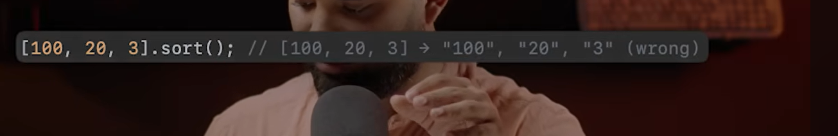

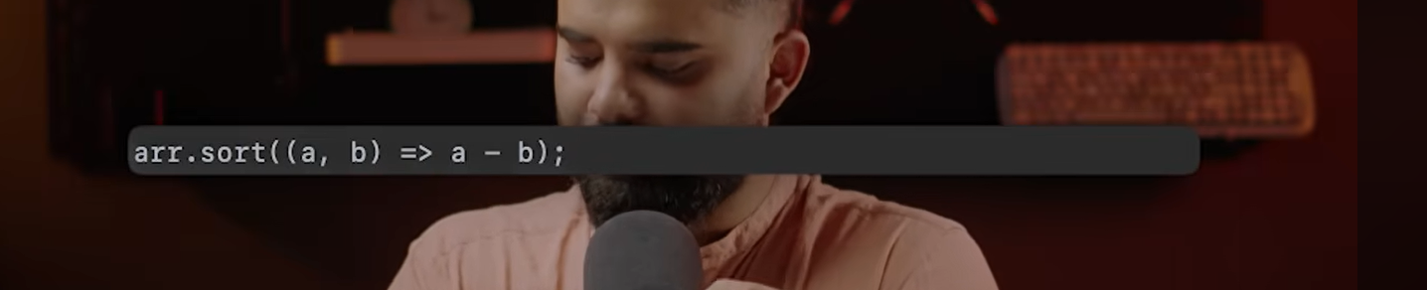

Sahi tarikay sy sort ho ga with parameter and compare value.

🧱 Chapter 8: Objects

🧠 What is an Object?

Objects in JavaScript are like real-world records – a collection of key-value pairs. They help us store structured data (like a student, a product, or a user profile).

Example:

Acess ham ny value karni hai dot ky sath or value like name hai to name

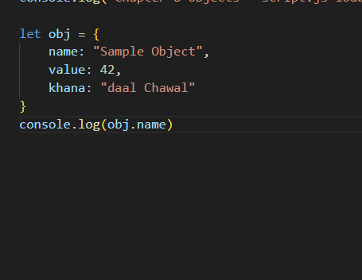

Aik or tarhaan bi ham is ko aces kar sakhty hai jasay.

Example:

Aik or tarika bi hai jiss ki madad sy ham log object ky ander square bracket ky ander single quotes main value aces skar sakhty hai.

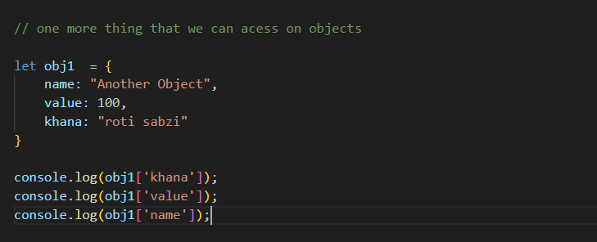

Convert Name in Object:

Basically ye jo obj hai ye variable main hai or object ky ander is ko acess kar rha hai.  
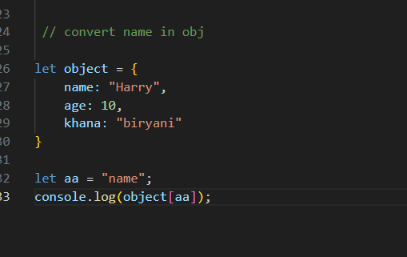

Key – value Structure:

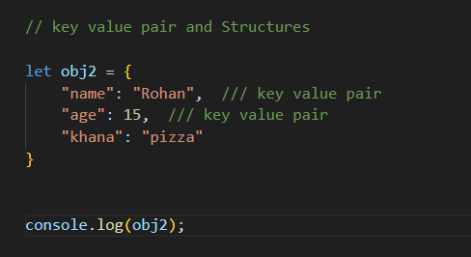

Nesting and deep acess:

Nesting and deep acess:

Aik object ky ander dusra object or dusray object ky ander third one is called nesting object.

Deep acess means the dotdotdot

Example:

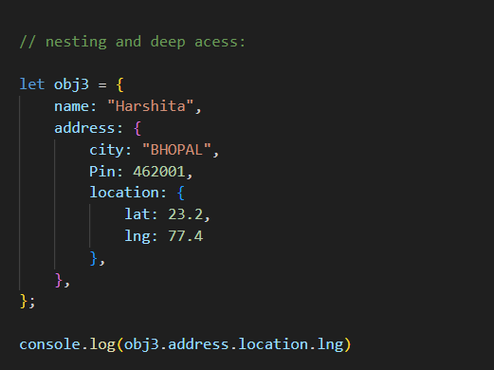

Object destructing:

Means ky ap ko bar bar obj4.address.location bar bar nahi likhna par rha hai ap ko sirf wo aik variable amin tore kar ky use kar di hai usy destructing khty hai

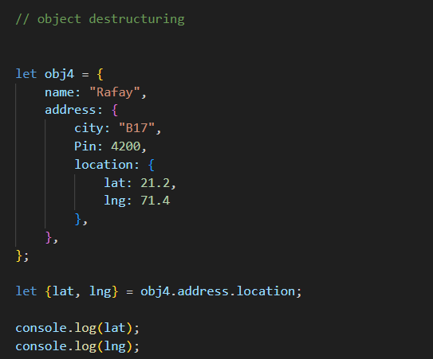

Looping

There are three types of object

1. For-in
2. Object.keys
3. Object.entries

For – In:

In main jo hai For – in loop main aik keys hamay mil rhi hai amay value chaiye object name []  
Example:  
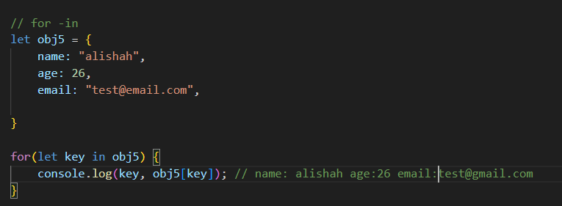

Object.keys:

Is main jo ha wo object ko aik array main convert kar deti hai.

Example:

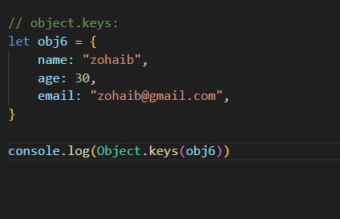

Object.entries:

Means ky aik object ky ander aik array or array ki object.entries khty hai.

Example:

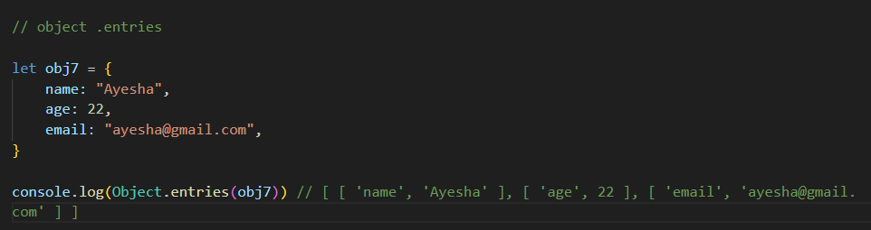

Coping Object & spread operator:

Example:

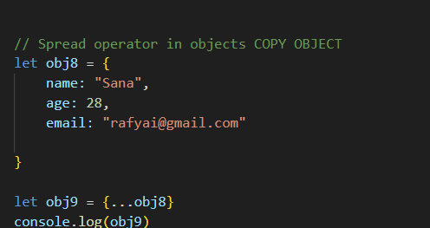

Object.assign:

Main {} object and then woi obj or phir copy ho gya.

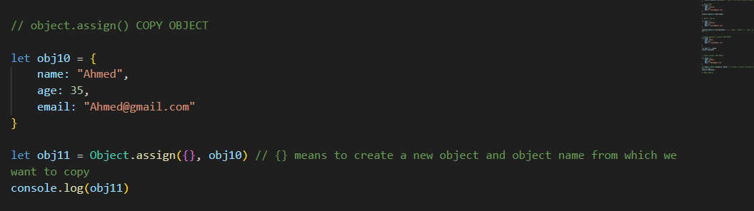

Example:

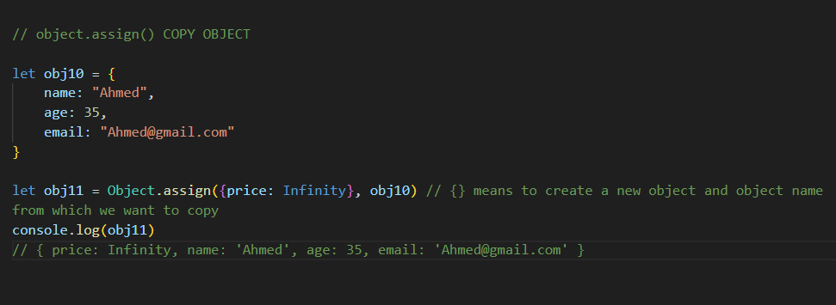

Deep Clone:

Agr ap ka object galti sy nested object bana to copy

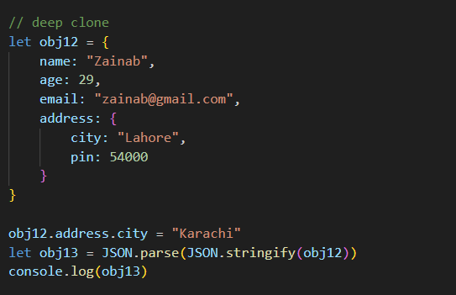

Optional Chaining:

Main ham log ? ka isltamal kartay hai object ky ander shahid addresses ho bi sakhty hai nahi bi ho sakhty agr hai to laoo nahi hai to na laoo

Example:

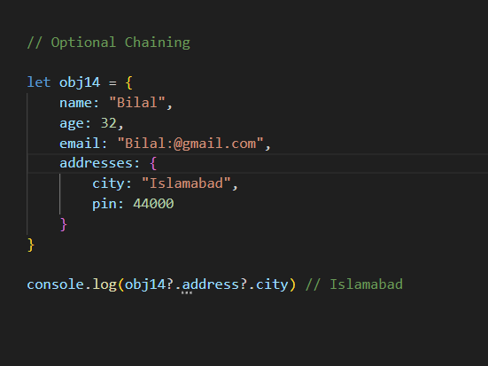

Computing properties:

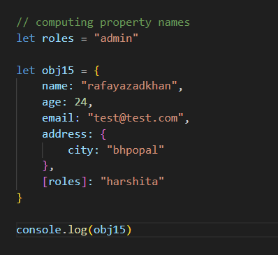

Practice Question:

Problem 1:

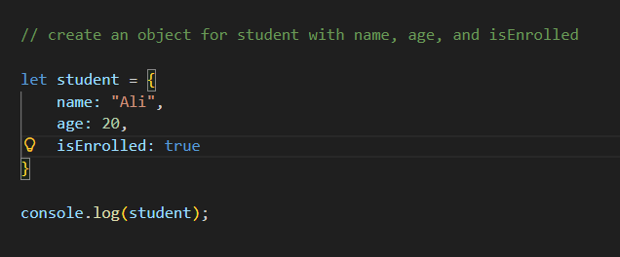

Problem 2:

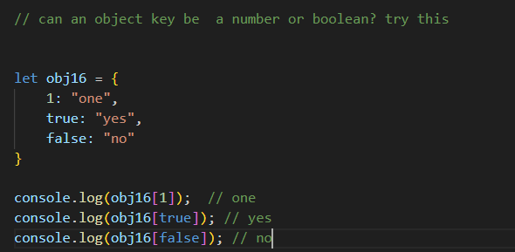

Problem 3:

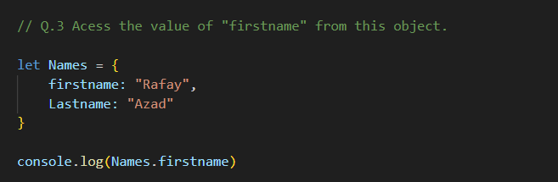

Problem 4:

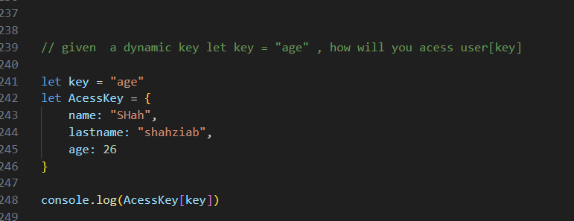

Problem 5:

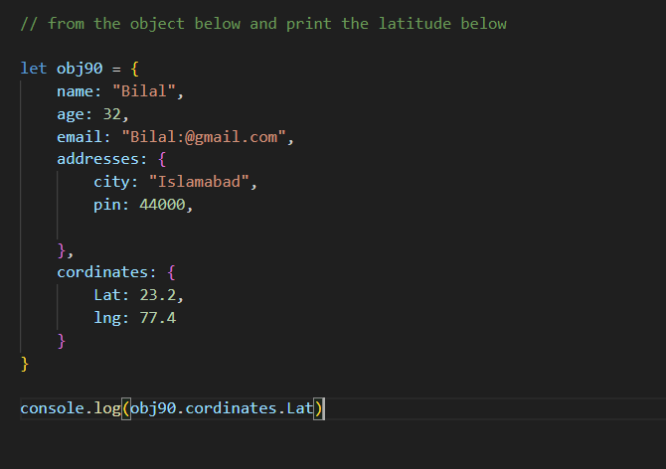

Problem6:

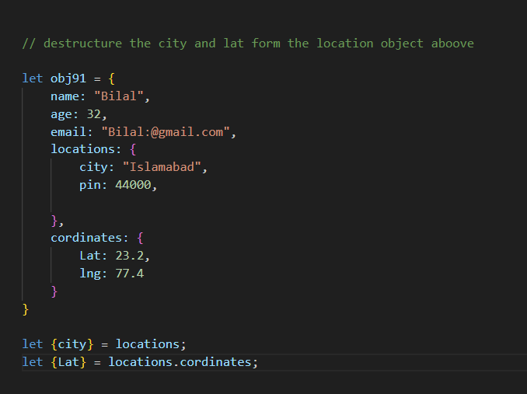

Problem 7:

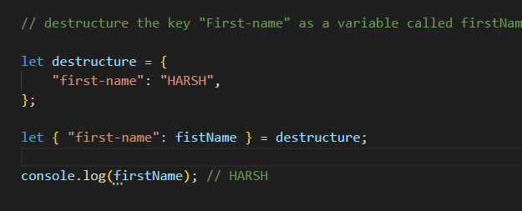

Problem 8:

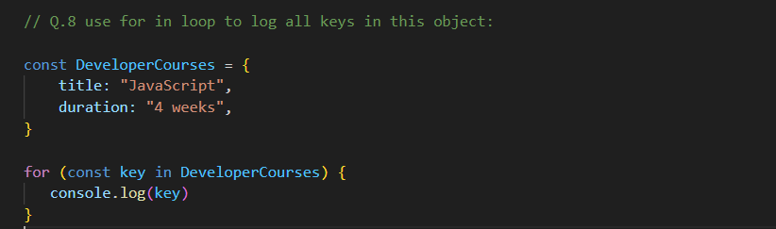

Problem 9:

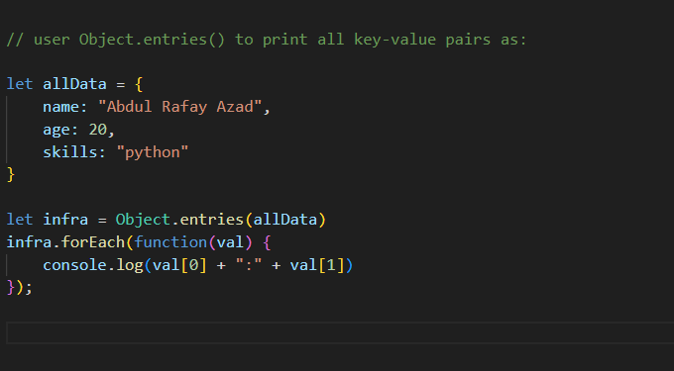

Problem 10:

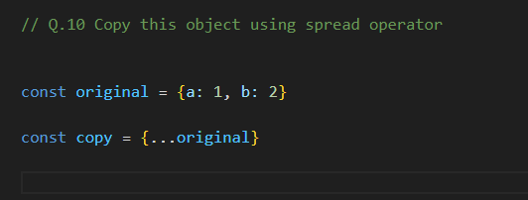

Problem 11:

Basically jab obj 1 main object hai or nested object hai jin ki wajha sy

Jab clone kia hai to puri tarhan sy copy nahi howa hai score ki value change ki hai 100 ho gi hai obj1 main 100 a gya hai.

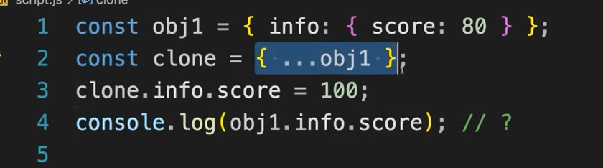

Problem 12:

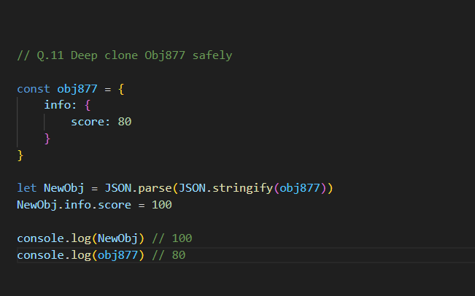

Problem 13:

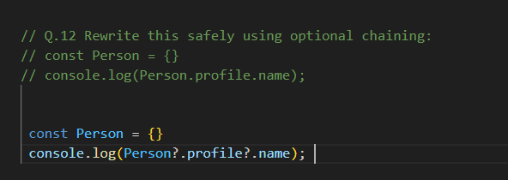

Problem 14:

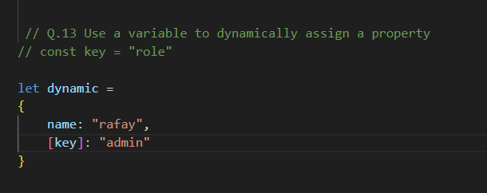

Confusion Points with Object:

Deep copy and shallow copy

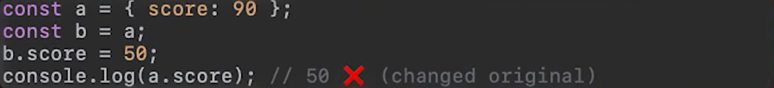

JSON.parse(Json.stringify(objectname))